Welcome to BTEC Sport & Exercise Science (Diploma): Course Start

Course Start is independent learning you need to complete as a fundamental part of your introduction to the course. It should take you approximately 5 hours to complete.

|  |  |
| --- | --- |
| How this **Course Start** fits into the first term of the course | Our Course Start looks directly at the Anatomy & Physiology work that students will study as soon as they begin. These will be exams that they will take in both first and second year. |

|  |  |
| --- | --- |
| How will my **Course Start** learning be used in lessons? | Course Start will be used for students when opening their skeletal and muscular system topics. Students will look at Sports Coaching to link to their starting coursework unit, which will involve their planning for sport sessions. |

|  |  |
| --- | --- |
| **Course Start** learning objectives | * Demonstrate knowledge and understanding of body systems and how they respond and adapt to exercise in different environments * Demonstrate knowledge and understanding of the language, structure, characteristics and function of each anatomical system * Demonstrate knowledge and understanding of psychological factors, concepts, interventions and theories in sport and exercise activities * Explore practices, adaptations and measures used to develop performance and fitness |

|  |  |
| --- | --- |
| What are the **expectations** in A Level PE and what does the course involve? | Our specification is: [BTEC Level 3 Sport & Exercise Science](https://qualifications.pearson.com/content/dam/pdf/BTEC-Nationals/sport-and-exercise-science/2016/specification-and-sample-assessments/9781446938072-btec-nat-dip-ses-spec-iss2c.pdf)  This course involves:   * Completing external exams for Functional Anatomy, Exercise Physiology and Sport Psychology. * Taking part in regular enrichment activities. * Taking part in fitness tests and training ready for use in assignment work. |

**BTEC Sport & Exercise Science**

**-----------------------------------------------------------------------**

**COURSE START WORK 2025**

Hello again, this is your Course Start task to be completed before your first lesson in college. This is an extension of the year 11 preparation work that you hopefully completed over the summer.

On the following pages you will find the worksheet to complete -

1. ‘**Sports Coaching** - Skills and Techniques - What, How and Why…’
2. ‘**Anatomy & Physiology** - Bones, Joints & movement analysis’
3. ‘**Sport Psychology** - Psychological Performance Profiling’

The performance of sport itself is central to any sports programme, it is therefore essential we examine this in great detail and continue to build our understanding of performance as we progress through the different topics on your course.

This work will contribute towards your **Sports Coaching** (Unit 6), **Functional Anatomy & Exercise Physiology** (Unit 1 & 2) and **Sport Psychology** (Unit 3).

We look forward to seeing you all soon.

The PE & Sport Team

**Sports Performance - Skills and Techniques - What, How and Why...**

You are required to **select a sport** that you currently play or are interested in.

You then need to complete the table on the following page to **examine three skills performed** in this sport.

* For each skill you should present the techniques employed or coaching points followed to perform effectively - **how you do it.**
* You should then look into **HOW to improve this skill**. You need to create or find a drill/exercise that will help to improve this skill. You need to state how this drill will help to improve the athlete’s quality in this area.
* You need to then find a video link or image, which will show the drill or a similar drill in action. If you need to draw out a session plan of what this looks like and upload the picture, please do so.

*Recommended Resources;*

*National governing body websites - coaching cards / PE teaching resources - websites - teachpe.com, ukcoaching.org, etc*

**Sports Coaching - Skills and Techniques - What it is and how to improve it.**

|  |  |  |  |
| --- | --- | --- | --- |
| **SPORT** |  | | |
| **SKILLS** | **Coaching Points/Technique;**  **Explain how this skill is performed** | **Can you think of a drill that could be used to improve the performance of this skill? Explain how this drill can be used to improve the athlete’s performance** | **Picture or video link of this drill being used** |
| 1 |  |  |  |
| 2 |  |  |  |
| 3 |  |  |  |

**Anatomy & Physiology - Bones, Joints & Movement analysis**

**Skeletal System**

Use the video to answer the following questions and worksheets: [The Skeletal System | Sport Science Hub: Physiology Fundamentals | Music Version](https://www.youtube.com/watch?v=m_tsmZ2dL_Q)

1. Draw arrows to Identify the names of the major bones of the skeleton in the image of the runner below
2. In each box describe which bones are meeting at each joint?

**Shoulder**

**Elbow**

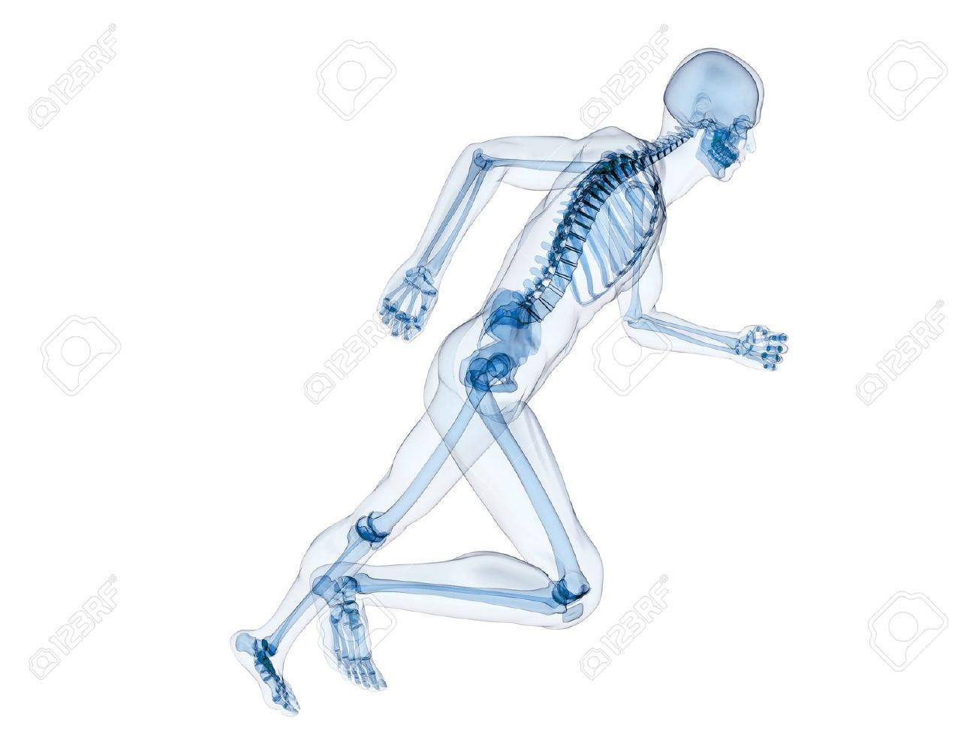

**Hip**

**Wrist**

**Knee**

**ANALYSIS OF THE SKELETAL & MUSCULAR SYSTEMS - HOW THEY PRODUCE MOVEMENT IN SPORT AND EXERCISE**

**Ankle**

Pick a sporting movement of your choice & use this worksheet to help you answer the Q’s: [Copy of Human Movement Patterns - Task Sheet](https://docs.google.com/document/d/1wTpTQ3vfHQtHLv6Ka7kkkRoafAXp31DoJ8xs921RzNs/edit?usp=sharing)

1. Find pictures / draw a diagram to show the **preparation** and **execution** phases of movement from different planes of motion
2. Complete the second table for each of the major joints working during the action.
3. Explain this in your own words in writing underneath.

|  |  |
| --- | --- |
| PREPARATION | EXECUTION |
|  |  |

|  |  |  |  |  |  |  |
| --- | --- | --- | --- | --- | --- | --- |
| Joint | Type of joint | Articulating bones | Movement | Plane of movement | Muscle roles; (agonist/antagonist - synergist/fixator) | Muscle contraction types |
| Knee |  |  |  |  |  |  |
| Elbow |  |  |  |  |  |  |
| Shoulder |  |  |  |  |  |  |

**Sport Psychology & Profiling - Psychological Interventions**

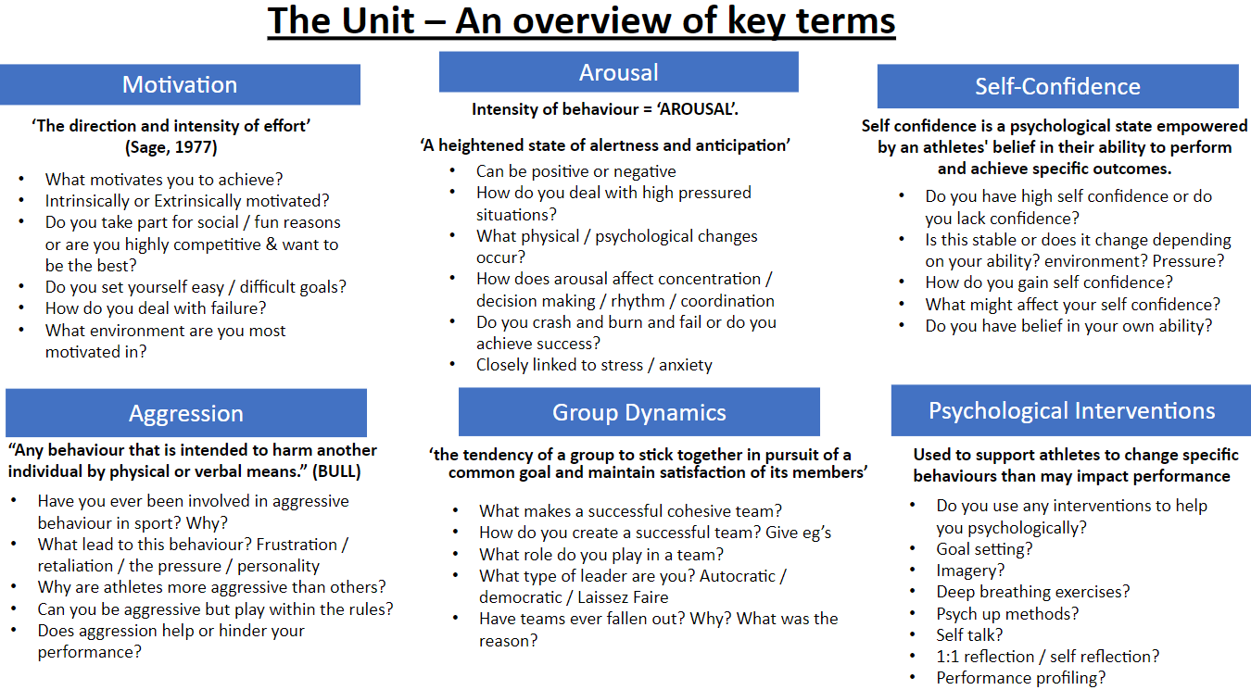

|  |  |  |
| --- | --- | --- |
| **Self Analysis:** *Use the key term sheet above as a guide and write an evaluation on your OWN psychological mindset for your chosen sport.* | | |
| Sport case study: | | |
| Motivation | Arousal | Self-Confidence |
|  |  |  |
| Aggression | Group Dynamics | Psychological Interventions |
|  |  |  |