

**Course Start**

Course Start is independent learning you need to complete as a fundamental part of your introduction to the course. It should take you approximately 5 hours to complete.

|  |  |
| --- | --- |
| Course Name | **Level 3 AAQ BTEC National in Health & Social Care** |
| How this **Course Start** fits into the first term of the course | In the first term you will be completing your first piece of coursework exploring health promotion and education in H&SC. |
| How will my **Course Start** learning be used in lessons? | Your completed course start work will be used in lessons to:   * provide you with the data needed to explain how different health issues are *impacting* the health of the population * provide you with the knowledge on which organisations are involved in monitoring the health of the population so you can start to discuss *how and why the nation’s health is closely monitored* * provide you with knowledge of health education campaigns which you will then use to *develop your own health campaign* |
| **Course Start** learning objectives | 1. To familiarise yourself with some of the major health issues impacting the health of the population. 2. To develop research skills to locate health data and present the information in a logical way. 3. To familiarise yourself with the organisations involved in monitoring the health of the population 4. To familiarise yourself with the aims of major national health education campaigns |
| Study Skills | * Literacy   - reading given article  - writing up notes to meet the task brief   * Research   - using the internet or other sources   * Numeracy   - using statistical data |

**Expectations for: Health and Social Care**

Our specification is the [AAQ BTEC National in H&SC](https://qualifications.pearson.com/en/qualifications/btec-nationals/health-and-social-care-aaq.htm)

|  |
| --- |
| **What this course involves:** Two units in Year 1: |
| **Unit 5 Promoting Health Education** |
| Coursework Unit  Completed September - December 2025  Worth 25% of total qualification  In this unit you will develop an understanding of the purpose of health education, learning about organisations and legislations that support the implementation of health education including how they work in an integrated way to ensure the nation’s health is a priority.  You will also explore a range of models and approaches to health education that will be used to support you writing your own small-scale health education event. |
| **Unit 1 Human Lifespan and Development** |
| Exam Unit  Completed January - May 2026  Exam in May 2026 (1.5hrs long)  Worth 25% of total qualification  When working in H&SC, professionals will be caring for and supporting service uses from all life stages.  In this unit you will first develop your knowledge and understanding of how people develop **physically, intellectually, emotionally and socially** **(PIES)** across different life stages and how these 4 areas impact each other.  You will then study **factors** that may influence a person’s **PIES**, some of these are innate; some are impacted by lifestyle, environmental, socio-economic factors and many are a combination of all factors. You will study the impact of health inequalities, and how these affect the health of individuals.  The unit also explores the promotion, prevention and treatment provided by health and social care professionals and the roles and responsibilities of health and social care professionals when providing effective, holistic care across a range of health conditions. |

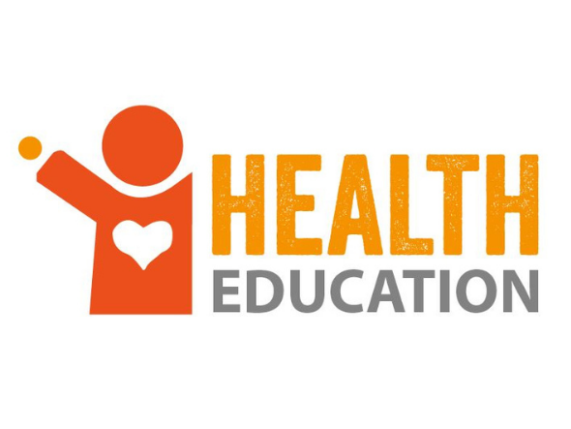

**Health and Social Care: Course Start Work**

|  |
| --- |
| In Unit 5 Promoting Health Education, we look at how health issues are monitored and the development of health education campaigns.  **You need to know how much specific health issues are impacting the health of the population locally (in Brighton & Hove) and nationally (in England).**  **You also need to know who is involved in monitoring health data and national public health education campaigns which have been developed to improve people’s health.** |

To develop health education programmes, we first of all need to understand the major health issues impacting the population.

|  |
| --- |
| **Task 1: Health Issues** |

For the following health issues, outline how they can negatively impact a person’s health and wellbeing (physical, mental, emotional, social):

* Smoking
* Diet & Nutrition (poor diet)
* Alcohol
* Pollution

**You can produce this information** in a table format, or as an information poster, or as a spider diagram. Please try to keep it to one A4 page only!

Also, ensure everything you research is written in your own words!

|  |
| --- |
| **Task 2: Finding Health Data** |

How are these health issues specifically impacting Brighton & Hove?

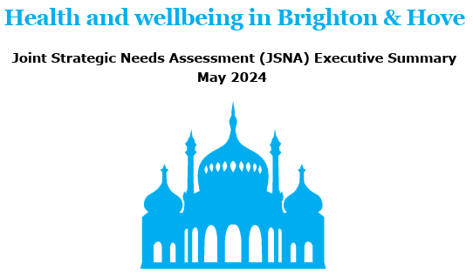Look through the following [Brighton & Hove JSNA report](https://www.brighton-hove.gov.uk/sites/default/files/2024-05/JSNA%20Executive%20Summary%20May%202024.pdf) to identify the following statistics *(you can copy and paste the table into your work)*:

|  |  |  |  |
| --- | --- | --- | --- |
| [Link](https://www.brighton-hove.gov.uk/sites/default/files/2024-05/JSNA%20Executive%20Summary%20May%202024.pdf) | B+H Statistics | England Statistics | Comparison Notes:  (who is worse or better) |
| Adult mortality (death) caused by air pollution *(page 7)* |  |  |  |
| Percentage of adult smokers  *(page 11)* |  |  |  |
| Percentage of adults overweight or obese  *(page 11)* |  |  |  |
| Hospital admissions for alcohol specific conditions  *(page 11)* |  |  |  |

**Stretch and Challenge Task:**

Exposure to air pollution and taking part in certain lifestyle factors can raise the risk of disease, including certain cancers. Using the ‘[Cancer in Brighton and Hove 2022’ report](https://www.brighton-hove.gov.uk/sites/default/files/2023-04/Cancer%20JSNA%20Final.pdf), find the following cancer health statistics *(you can copy and paste the table into your work)*:

|  |  |  |  |
| --- | --- | --- | --- |
| [Link](https://www.brighton-hove.gov.uk/sites/default/files/2023-04/Cancer%20JSNA%20Final.pdf) | B+H Stats | England Stats | Comparison Notes:  (who is worse or better) |
| All cancers caused by **alcohol** consumption  (section 6.2 on page 25. See top paragraph and Fig 14.) | For every 100,000 people, the number of **males in B+H** with alcohol related cancer is:  For every 100,000 people, the number of **females in B+H** with alcohol related cancer is: | For every 100,000 people, the number of **males in England** with alcohol related cancer is:  For every 100,000, people the number of **females in England** with alcohol related cancer is: | For Males:  For Females: |
| **Smoking** attributable deaths from cancer  (section 10.4 on page 37. See Fig.39) |  |  |  |

**Obesity** caused by poor diet increases the risk of people being diagnosed with type 2 diabetes. Use the [following link](https://fingertips.phe.org.uk/diabetes-ft#page/3/gid/1938133439/pat/15/par/E92000001/ati/502/are/E06000043/iid/94192/age/164/sex/4/cat/-1/ctp/-1/yrr/1/nn/nn-15-E06000043/cid/4/tbm/1/page-options/car-do-0) to locate statistics from the Office for Health Improvements & Disparities (OHID) which shows:

|  |  |  |  |
| --- | --- | --- | --- |
| [Link](https://fingertips.phe.org.uk/diabetes-ft#page/3/gid/1938133439/pat/15/par/E92000001/ati/502/are/E06000043/iid/94192/age/164/sex/4/cat/-1/ctp/-1/yrr/1/nn/nn-15-E06000043/cid/4/tbm/1/page-options/car-do-0) | Brighton & Hove | England | Comparison Notes:  (who is worse or better) |
| % of the population with type 2 diabetes  *(look at the* ***‘value’*** *column and this will tell you the %)* |  |  |  |

|  |
| --- |
| **Task 3: Organisations involved in monitoring health** |

Many different organisations are involved in the monitoring of health in the UK which then influences the development of health education campaigns.

Research the following organisations to find out who they are, what they do/what their aims are in supporting a healthier nation:

* **World Health Organisation (WHO)** <https://www.who.int/about>
* **Department for Health and Social Care (DHSC)** <https://www.gov.uk/government/organisations/department-of-health-and-social-care/about>
* **Local Authorities e.g. Brighton and Hove council** <https://www.local.gov.uk/publications/councillors-guide-local-authority-public-health-responsibilities-0#:~:text=>

**Stretch and Challenge Task:**

Can you also repeat this task but now include:

* **UK Health Security Agency (UKHSA)** <https://www.gov.uk/government/organisations/uk-health-security-agency>

**You can produce this information** in a table format, or as an information poster, or as a spider diagram. Please try to keep it to one A4 page only!

There is more information provided on the webpages than you will need, so you will need to read through the information carefully and select only what is relevant to write up in your own words!

|  |
| --- |
| **Task 4: Health education campaigns** |

When we have established what the health issues are and how much they are impacting the health of the population, the organisations involved in the monitoring of health can then work to develop a health education campaign to improve the health of the nation.

These can be NATIONAL campaigns or they can be developed at a LOCAL level e.g. for Brighton and Hove.

***Select 2 health issues*** from the table below and research the following information about 2 health education campaigns already up and running:

* name of the campaign
* name of organisation running *(you may have to Google ‘who runs…’)*
* the health issue it is targeting
* target audience
* aim / goal of the campaign
* strategies used
* evidence of success *(you can ask Google ‘what impact’ or ‘how successful has the campaign had?’)*
* your opinions (WWW and what do you think could be EBI?)

|  |  |  |
| --- | --- | --- |
| **Health Issue** | **Name of Health Education Campaign** | **Weblinks to get you started** |
| Diet & Nutrition | Better Health Adult Obesity | <https://campaignresources.dhsc.gov.uk/campaigns/better-health-adult-obesity/>  <https://www.nhs.uk/better-health/lose-weight/> |
| Smoking | Stoptober | <https://www.gov.uk/government/news/stoptober-launches-to-give-smokers-the-confidence-to-quit> |
| Pollution | Clean Air Day | <https://www.globalactionplan.org.uk/clean-air/clean-air-day> |
| Alcohol | Dry January | <https://alcoholchange.org.uk/help-and-support/managing-your-drinking/dry-january> |

|  |
| --- |
| **Task 5: Public Health in the News** |

Download the BBC News app or visit the BBC News website.

Over the summer holidays try to regularly look at the ‘Health’ news articles (such as once a week) and select an article which could be about a health issue or a health education campaign impacting health in the UK.

For example, 2 interesting articles from June 2025 include:

* School sun safety lessons trialled <https://www.bbc.co.uk/news/articles/czjkex0errko>
* Government informs supermarkets to make healthy food more appealing <https://www.bbc.co.uk/news/articles/ckg5xzpmxzgo>

**Come back in September with an article or 2 that you found particularly interesting / important to you.**