**Course Start**

Course Start is independent learning you need to complete as a fundamental part of your introduction to the course. It should take you approximately 5 hours to complete.

|  |  |
| --- | --- |
| Course Name | **GCSE Biology** |
| How this **Course Start** fits into the first term of the course | Most students will have studied some GCSE Biology previously.  Although we will start at the beginning and cover all of the topics.  These tasks will help to remind you of some of the things you already know. |
| How will my **Course Start** learning be used in lessons? | Being familiar with the topics, basic biological principles and terminology will make your learning easier during the course. |
| **Course Start** learning objectives | * Understand the terminology used in GCSE Biology * Revise Basic Biological Principles * Use books and Revision guides to find information |
| Study Skills | * Research skills to find information * Communication skills - putting your ideas and findings into words * Data analysis - understanding scientific table and graphs * Mathematical skills- be able to carry out calculations |

**Expectations for: GCSE Biology**

Our specification is: [AQA GCSE Biology Specification](https://cdn.sanity.io/files/p28bar15/green/510eb7c76df13be23292df4392de95eb32b0d30f.pdf)

|  |
| --- |
| **What this course involves** |
| Purchase of a revision guide and workbook at the beginning of the course (we will order these for you). |
| Spend 5 hours each week outside of lesson times on independent study. |
| Complete homework tasks on time. |
| Complete the relevant pages in the work book after each lesson. |
| Come to lessons prepared with all the materials you need. |
| Use of maths skills, including calculations and analysing tables and graphs. |

**Getting and staying organised**

The key to level 2 success is good organisation; keeping your notes in good order and keeping track of progress through the course is essential.

Get yourself a large folder (just for Biology) with a set of dividers and file your notes at the end of each short section. You will also need to get a smaller folder for transporting notes to and from college, and for keeping your current notes in.

**Bring paper, a pencil, calculator and pens to every lesson.**

You will buy a textbook and a workbook which supports your GCSE Biology course which you should also bring to every lesson.

**Preparation and reading ahead**

You should do regular background reading (from the textbook and online resources) and keep up to date with the workbook, particularly important if you miss a lesson for some reason.

**Homework**

You will be set homework each week, generally written homework, and mostly from your workbook.

**Now watch some videos**

The following short videos should help to refresh your general biology knowledge and skills and set you off on the right track.

* Cells - [GCSE Biology - Cell Types and Cell Structure #2](https://www.youtube.com/watch?v=qHkUOlC8Nbo)
* Organisation - [GCSE Biology - Levels of Organisation - Cells, Tissues, Organs and Organ Systems](https://www.youtube.com/watch?v=MB6mE6weCS4)
* Infection & response - [Science - GCSE- Biology - Aqa- Infection and Response: The Four Pathogen Types](https://www.youtube.com/watch?v=GxbNUI7x270)
* Digestion - [GCSE Biology - Digestive System #18](https://www.youtube.com/watch?v=vMI46qGQMDw)
* Respiration [GCSE Biology - Respiration #21](https://www.youtube.com/watch?v=U4WwWuVZSe4)
* The Nervous system - [GCSE Biology - Nervous System and Reflex Arc #58](https://www.youtube.com/watch?v=HiuXfbwND9s)
* Transport in Plants - [GCSE Biology - Transport in plants - Translocation (Phloem) and Transpiration (Xylem) #51](https://www.youtube.com/watch?v=9FTafxnbwHQ)
* DNA and Genes - [GCSE Biology - DNA Part 1 - Genes and the Genome #63](https://www.youtube.com/watch?v=wv1TQXBQ6wQ)

Then try answering the questions below. You can either:

* Print the pages and fill in the answers with a pen.
* Save a copy of the document and fill in electronically then print.
* Complete electronically and email to [jf@varndean.ac.uk](mailto:jf@varndean.ac.uk)

Have a go. You may well find some of it difficult but persevere or see if you can work with someone. Look up anything you are not sure of.

**1.** **Figure 1** showscells containing and surrounded by oxygen molecules.

Oxygen can move into cells or out of cells.

**Figure 1**

Cell A

Cell B

Cell C

Cell D

Oxygen molecules

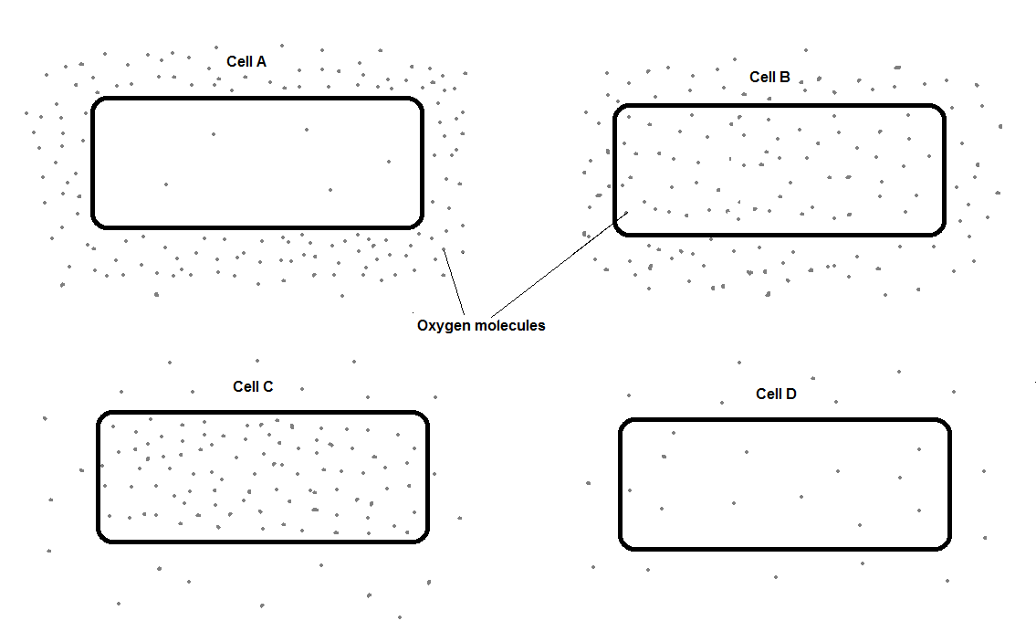

**1.1** Into which cell, **A**, **B**, **C** or **D**, will oxygen move the fastest?

**[1 mark]**

**A** 

**B** 

**C** 

**D** 

**1.2** Use words from the box to complete the sentences.

**[2 marks]**

|  |  |  |
| --- | --- | --- |
| **active transport** | **diffusion** | **membranes** |
| **mitochondria** | **nuclei** | **osmosis** |

Oxygen is taken into cells by the process of ____________________ .

The parts of cells that use the most oxygen are __________________ .

**1.3** Which process produces oxygen in some cells?

Tick **one** box.

**[1 mark]**

**Diffusion** 

**Photosynthesis** 

**Protein** **synthesis** 

**Respiration** 

**2.** Some scientists investigated the rates of absorption of different sugars by the small intestine.

In one experiment they used a piece of normal intestine.

In a second experiment they used a piece of intestine poisoned by cyanide.

Cyanide is poisonous because it prevents respiration.

**Table 2** shows their results.

**Table 2**

|  |  |  |
| --- | --- | --- |
|  | **Relative rates of absorption** | |
| **Sugar** | **Normal intestine** | **Intestine poisoned by cyanide** |
| Glucose | 1.00 | 0.33 |
| Galactose | 1.10 | 0.53 |
| Xylose | 0.30 | 0.31 |
| Arabinose | 0.29 | 0.29 |

**2.1** Name **two** sugars from **Table 2** which can be absorbed by active transport.

**[2 marks]**

________________________________________________________________

_______________________________________________________________

**2.2** Use evidence from **Table 2** to explain why you chose these sugars.

**[4 marks]**

________________________________________________________________

________________________________________________________________

________________________________________________________________

________________________________________________________________

________________________________________________________________

**2.3** All of the sugars named **Table X** can be absorbed by diffusion.

Explain how information from **Table X** provides evidence for this.

**[2 marks]**

________________________________________________________________

________________________________________________________________

________________________________________________________________

________________________________________________________________

**3.** The leaves of most plants have stomata.

**3.1** Name the cells which control the size of the stomata.

**[1 mark]**

________________________________________________________________

**3.2** Give **one** function of stomata.

**[1 mark]**

________________________________________________________________

**3.3** **Figure 5** shows part of the surface of a leaf.

**Figure 5**

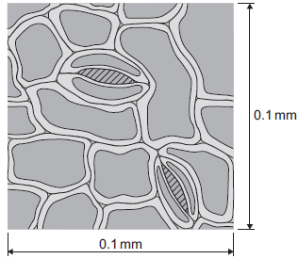

The length and width of this piece of leaf surface are both 0.1 mm.

Calculate the number of stomata per mm2 of this leaf surface.

**[2 marks]**

Number of stomata per mm = _____________

**3.4** A different plant species has 400 stomata per mm2 of leaf surface.

Having a large number of stomata per mm2 of leaf surface can be a disadvantage to a plant.

Give **one** disadvantage.

**[1 mark]**

________________________________________________________________

**3.5** A student investigated the loss of water from plant leaves.

The student did the following:

Step 1: took ten leaves from a plant

Step 2: weighed all ten leaves

Step 3: hung the leaves up in a classroom for 4 days

Step 4: weighed all ten leaves again

Step 5: calculated the mass of water lost by the leaves

Step 6: repeated steps **1** to **5** with grease spread on the upper surfaces of the leaves

Step 7: repeated steps **1** to **5** with grease spread on both the upper and lower surfaces of the leaves.

All the leaves were taken from the same type of plant.

**Table 2** shows the student’s results.

**Table 2**

|  |  |
| --- | --- |
| **Treatment of leaves** | **Mass of water the leaves lost in g** |
| No grease was used on the leaves | 0.98 |
| Grease on upper surfaces of the leaves | 0.86 |
| Grease on upper and lower surfaces of the leaves | 0.01 |

What mass of water was lost in 4 days through the upper surfaces of the leaves?

**[1 mark]**

________________________________________________________________

**3.6** Very little water was lost when the lower surfaces of the leaves were covered in grease.

Explain why.

**[3 marks]**

________________________________________________________________

________________________________________________________________

________________________________________________________________

**4.** Some forms of the Human Papilloma Virus (HPV) have been shown to cause cervical cancer.

Girls aged 11 to 14 now receive a vaccine for HPV.

Explain how the HPV vaccine could reduce the incidence of cancer.

Include in your answer:

* How the immune system responds to vaccines
* How giving girls the vaccine could reduce the number who get cervical cancer.

**[6 marks]**

________________________________________________________________

________________________________________________________________

________________________________________________________________

________________________________________________________________

________________________________________________________________

________________________________________________________________

**5.** **Figure 1** shows a cell from the small intestine.

**Figure 1**

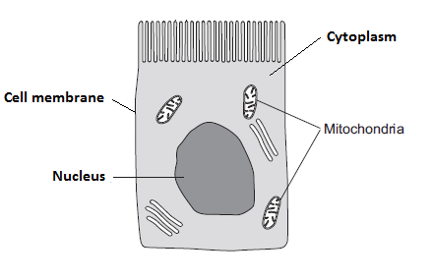

**5.1** Which part of the cell contains chromosomes?

Choose **one** part from the list.

**[1 mark]**

Cell membrane Cytoplasm Nucleus Mitochondria

**5.2** Chromosomes contain many genes. Genes have different forms.

What is the name given to different forms of a gene?

**[1 mark]**

________________________________________________________________

**5.3** Eye colour is controlled by genes.  
In a genetic diagram:

• B = brown

• b = blue

The genotype of one individual is bb.  
Which words can be used to describe the genotype of this person?  
Choose **two** words from the list.

**[2 marks]**

**Dominant Heterozygous Homozygous Recessive Phenotype**

**5.4** Tobacco plants have 48 chromosomes.

State how many chromosomes do tobacco plant pollen cells have.

**[1 mark]**

________________________________________________________________

**6.** Mitosis and meiosis are types of cell division.

**6.1** For each feature in the table, tick () **one** box to show if the feature occurs:

• only in mitosis

• only in meiosis.

**[2 marks]**

|  |  |  |
| --- | --- | --- |
| **Feature** | **Only in mitosis ()** | **Only in meiosis  ()** |
| Produces new cells during growth and repair |  |  |
| Produces gametes (sex cells) |  |  |
| Produces genetically identical cells |  |  |

**6.2** Name the organ that produces gametes (sex cells) in:

**[2 marks]**

A man ____________________

A woman __________________

**6.3** **X** and **Y** chromosomes are the sex chromosomes. They determine a person’s sex.

What sex chromosomes will be found in the body cells of a woman?

**[1 mark]**

________________________________________________________________

**6.4** A man and a woman decide to have a child.What is the chance that the child will be a boy?

**[1 mark]**

|  |  |  |
| --- | --- | --- |
| **Total Mark** | **Percentage (%)** | **Grade** |
|  |  |  |