2025

**Course Start**

Course Start is independent learning you need to complete as a fundamental part of your introduction to the course. It should take you approximately 5 hours to complete.

|  |  |
| --- | --- |
| Course Name | **Sociology A Level and AS Level** |
| How this **Course Start** fits into the first term of the course | This work feeds into the introductory lessons which are designed to help you to understand the sociological approach and the essential concepts that under-pin Sociology. |
| How will my **Course Start** learning be used in lessons? | The Course Start work will be taken in by your teacher to assess. Your understanding of the content will be checked and consolidated in the first few Sociology lessons. |
| **Course Start** learning objectives | * To give students an understanding of the concepts that under-pin Sociology and its approach to studying society. * To apply your own knowledge of society to different activities * To develop research skills |
| Study Skills | * Independent Learning * Meeting deadlines * Application of knowledge * Research skills |

**Expectations for: Sociology AS and A level**

Our specification is: AQA

|  |
| --- |
| **What this course involves:** |
| Completing Planned Study (independent learning) of 5 hours per week - checked weekly. |
| Written work involving a range of practice exam questions (e.g. short answer questions worth 4 marks, up to extended essays worth 30 marks).  Prepared for at home, but written in timed conditions in class. |
| Engaging in a range of activities in lessons e.g. independent work, group work, discussions, research tasks. |
| Accessing and using different learning applications e.g. Google Classroom, Quizlet and Seneca. |
| Accessing the course textbook and using it for planned study (and some lessons). |
| Application of Sociological theories and research methods to different topic areas. |
| Application of the core themes of: socialisation, culture and identity; and social differentiation, power and stratification to different topic areas. |
| Being organised: using the exercise books you will be given for classwork; developing revision skills; meeting deadlines; arriving at lessons on time and ready to work. |

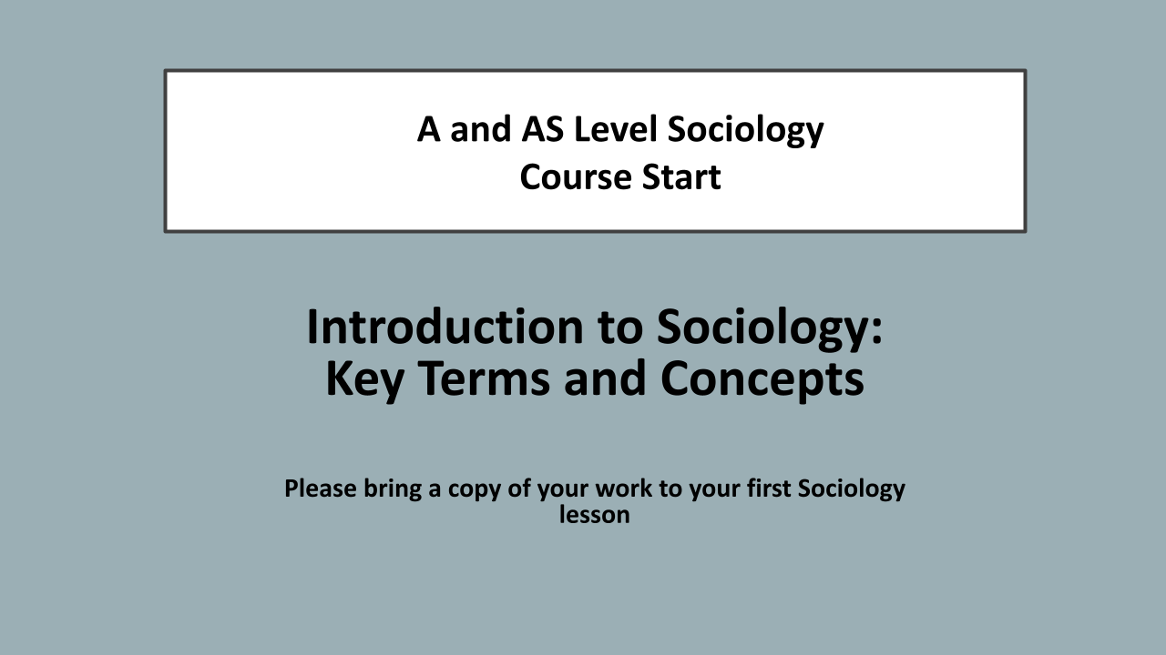

## There are 6 activities to complete

**Read through this booklet and complete all SIX activities at the end and bring your work to your first Sociology lesson.**

**SECTION 1**

**Becoming human:**

Why do human beings behave the way they do? Naturalistic explanations are those which assume that various kinds of human behaviour are natural or based on innate (inborn) biological characteristics. Theorists who believe this position argue that human behaviour then is a matter of *instincts -* biological predispositions that tell us 'instinctively' what we should do. Instincts are something we are born with rather than something we learn. A great deal of animal behaviour seems to be ruled by instincts. For example, birds seem to follow fairly fixed patterns of behaviour as if they were a set part of their 'nature'.

Nowadays, a popular explanation for human behaviour is to look for the answer in our genes. People vary in their genetic make-up and this might explain why they behave differently. Some scientists claim there is a gene for crime, one for alcoholism.

If this were the case, then one would expect human behaviour to be the same in all societies. Sociologists accept that humans have natural *reflexes -* for example, we automatically flinch when someone strikes us. They also accept that we have certain biological *needs* that must be met - for example, the need for food and drink. But sociologists believe that human behaviour is too complex and diverse to be explained in simple biological or genetic terms. Rather, they see our actions as the result of our social and cultural environments. We *learn* to think and act in certain ways. And it is our *culture* which teaches us how we should think and act.

**SECTION 2**

**Socialisation, Culture and Identity:** Shared meanings and values

Sociologists usually define culture as the shared meanings, values and norms of a society or group.

Meanings: Stuart Hall (1997) describes some of the key features of cultural meanings. First, it is largely thanks to *language* that humans are able to create meanings and make sense of the world. It is through language and other symbols, for example visual images, that people express their emotions and thoughts and communicate with one another. Second, culture is about *shared* meanings. People produce meanings together and so over time each social group builds up shared understandings of the world. Third, humans are constantly creating new meanings and revising old ones - so culture can be seen as a process or activity.

**Meanings** are things which give sense and significance to people's experiences.

Values are things we regard as important, the most significant standards or principles in our lives. Love is an obvious example. Other examples are religious convictions and political loyalties. In everyday life, most people believe in the values of honesty, consideration towards others, justice and fairness.

**Values** are beliefs about what is important, what is worth having, what is right and wrong

Norms are social expectations or rules about how people should or should not behave - for example, you should hold the door open for others, you should not grab the last biscuit. There are different rules for different situations -you can let your hair down at an end-of-term party, but the same behaviour would be frowned upon during normal class time. Norms also vary in their degree of seriousness. Committing murder will result in severe legal punishment but bad table manners might only provoke irritation in others.

**Norms** are social expectations or rules about how people should behave. Guides to behaviour.

Socialisation is the lifelong process by which people learn the culture of the society in which they live. Socialisation is carried out by agencies of socialisation, such as the family, the education system, religious institutions or the mass media

**Values - The Cheyenne**

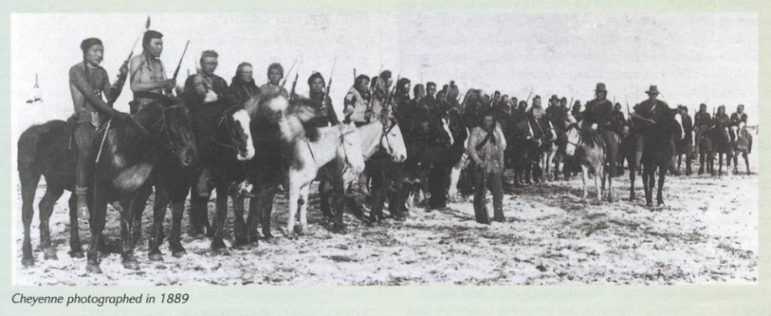

A value is a belief that something is good and worthwhile. It defines what is worth having and worth striving for. Values often vary from society to society.

The Cheyenne Indians lived on the Great Plains of the USA west of the Mississippi River and East of the Rocky Mountains. Their traditional way of life came to an end at the close of the 19th century when they were defeated by the US army and placed on reservations.

The Cheyenne believe that wealth in the form of horses and weapons is not to be hoarded and used by the owner but instead it is to be given away. Generosity is highly regarded and a person who accumulates wealth and keeps it for themselves is looked down on. A person who gives does not expect an equal amount in return. The greatest gift they can receive is prestige and respect for their generous action.

Bravery on the battlefield is one of the main ways a person can receive high standing in the eyes of the tribe. Killing an enemy, however, does not rank as highly as a number of other deeds. Touching or striking an enemy with the hand or weapon, rescuing a wounded Comrade or charging the enemy alone are amongst the highest deeds of bravery. The values of Cheyenne society provide goals for its members to aim to and general guidelines for their behaviour. Values are learned and shared by members of society. Some sociologists argue that shared values form the basis of social unity or social solidarity. They help to bind people into a close-knit group. Because they share the same values, members of society are likely to see others as 'people like themselves'. Therefore they will have a sense of belonging and feel part of a wider social group - part of a wider society.

**SECTION 3**

### Norms

Norms are specific guidelines for conduct. They define appropriate behaviour in particular situations. A society may value privacy but this value provides only a general guide to behaviour.

Norms guide behaviour in all aspects of social life. There are appropriate norms of dress which define the types of clothing appropriate for members of each sex, age group and social situation. There are norms governing behaviour with family friends, neighbours and strangers. There are norms which define acceptable behaviour in the home, classroom and workplace, at a party, wedding and funeral, in a cinema, supermarket and a doctor's waiting room.

As part of culture, norms are learned, shared and vary from society to society. This can be seen clearly from norms concerning food. Amongst the Bedouin of North Africa traditionally, sheep's eyes are regarded as a delicacy whereas in the West they are not usually considered fit to eat. The Bedouin eat with their fingers and a loud and prolonged burp at the end of the meal is a compliment to the host. In the West such behaviour would be considered bad manners. Or as a sociologist might say, it would not conform to the Western norms of eating behaviour.

Norms provide order in society. In a situation where anything goes the result can be chaos and confusion e.g., in a classroom where teacher and students fail to establish a set of rules about the conduct of a lesson. Norms help make social life predictable and comprehensible. If there were no norms stating how people express pleasure or irritation, warmth or hostility, it would be difficult to understand how others felt, to predict their behaviour and respond in appropriate ways.

### 

### SECTION 4

### Culture:

Linton (1945) puts it, *‘The culture of a society is the way of life of its members; the collection of ideas and habits which they learn share and transmit from generation to generation.’ It’s the language, beliefs, values and norms, customs, dress, diet, roles, knowledge and skills, and all the other things that people learn that make up the 'way of life' of any society*.

Culture is simply the way of life of a particular society or social group.

It includes language, beliefs, values and attitudes, norms of behaviour, customs, traditions and rituals, dress, music, diet, roles, knowledge and skills

Culture is essential to the operation of human society. Without shared meanings, people would be unable to communicate. Without shared values, they would be pulling in different directions. And without norms directing behaviour, there would be no order in society.

From a sociological viewpoint, human behaviour is primarily organised and directed by culture. We are not ruled by instinct, governed by our genes, or directed by biological needs and impulses. If we were, then human behaviour would be much the same in different times and in different societies. It isn't, as can be seen from the wide variation between cultures in different time periods and places.

Ralph Linton argues *“The culture of a society is the way of life of its members: the collection of ideas and habits which they learn, share and transmit from generation to generation.”*

There are 2 essential qualities of culture:

1. It is learned
2. It is shared (otherwise we would have confusion and disorder)

**SECTION 5**

**Stages of Socialisation - Primary socialisation**



The main most important component in primary socialisation is the family.

Children learn through imitation, some examples of this are movements, words, the way they walk. We learn this in the early years of our childhood from our parents, family and siblings.

Infants and children also learn rights and wrongs in life and consequences and awards for what they do. Such as we learn to eat with a knife and fork. For doing correct things we may get rewarded with a new toy and for doing something incorrect we may be sent to our bedroom.

Actions made by immediate family, family friends and siblings provide children with guidelines for actions. We may learn to play with certain toys, or how to act in a certain place and around certain people.

Close social relationships with other people are important in order for children to learn to interact and communicate. If children do not learn these skills it may be hard for them to grow up in society and therefore may be hard to interact with others.

Children who have been raised by wild animals (known as unsocialised children) have less of a chance at being able to talk and communicate so therefore will not be able to socialise. This minimises the chance of the child being able to talk and sometimes even the chance of the child acting like a human being.

Baumeister (1986) notes that family socialisation provides children with an identity. A baby has no life apart from its role in the family, therefore a child will believe that the family will love and care for it as long as it does what it is supposed to do.

Morgan (1996) suggests that a great deal of socialisation is concerned with social control and encouraging conformity (a social influence in behaviour or belief in order to fit in with a group).

Sanctions encourage a conscience in a child which will help them learn what is right and wrong and will help them in growing up. However sanctions and wrong and rights will change as a child gets older and moves into secondary socialisation.

Children will also learn what being a boy or a girl entails. Culture expectations will regard femininity and masculinity and therefore the children will need to learn the traditional gender roles.

Primary Socialisation and identity

* Identity refers to the understanding people hold about who they are and what is meaningful to them.
* Social identity refers to the characteristics that other people attribute to an individual, and it is our social identity that connects us to the people around us. They are the markers that indicate, at a very basic level, who we are.
* Baumeister (1986) says family socialisation provides children with an identity
* Young children have no life except its family role
* Social roles are and the significant roles and are played by the paren**ts**

**Stages of Socialisation - Secondary socialisation**

Secondary socialisation is carried out by other institutions outside of the family, and continues through the rest of our lives. Secondary socialisation happens in education, through the media, religion, jobs/workplace and from our peers.

**NOW COMPLETE ALL 6 ACTIVITIES ON THE NEXT PAGE and bring your work to your first lesson.**

**Expand your answers and write in full sentences.**

**Activity 1 -** *Using section 1 of the reading*

1. Do some research into the ‘nature versus nurture’ debate. What is it? What human behaviours are considered to be ‘natural’ and which are ‘nurtured’?

**Activity 2 -** *Using section 2 of the reading*

1. Define what we mean by values.
2. What are the values of traditional Cheyenne society?
3. What are the main values of British society?
4. How do the Cheyenne values differ from our society’s values?
5. Why are values important?

### Activity 3 - *Using section 3 of the reading*

1. What are norms?
2. Describe some examples of norms of British society?
3. Why are norms important in society?
4. Complete the table below:

|  |  |
| --- | --- |
| Things that other cultures consider to be food that your culture would not | Things that your culture considers to be food that others culture would not |
|  |  |
| What norms do our culture and others have governing how to eat (implements, manners, etc.)? | What norms do our culture and others have governing what should be eaten when (time of day/year, special occasions, etc.)? |
|  |  |

**Activity 4 -** *Using Sections 4 and 5 of the reading*

1. What is the difference between primary and secondary socialisation?
2. What is the main institution or agency that shapes a person’s primary socialisation?
3. Suggest three things that individuals learn from primary socialisation.
4. There are occasions where an individual will need to learn how to ‘fit into’ new situations and so experience re-socialisation. State three situations in which re-socialisation can happen.
5. Explain how primary socialisation within the family can be undermined by other agents of secondary socialisation. (How do the media or peers or schools teach different norms & values to those taught at home?)

**Activity 5**

There are several perspectives that run throughout sociology: Functionalism, Marxism, Feminism, Interactionism, Postmodernism.

1. Watch this video which gives an overview of the sociological perspectives: <https://www.tutor2u.net/sociology/reference/sociological-perspectives-introduction-to-sociology>
2. Choose ONE perspective to find out about in more detail.
3. Write a paragraph outlining the ONE sociological perspective/theory that you have researched into. What is their view of society? Try to use key terminology (concepts) in your answer.

**Activity 6**

The first topic we will look at in detail is Education and then we will study the research methods that sociologists use to study society. The final task is for you to carry out a very small scale piece of research. Follow the steps below.

1. **Gathering of Data -** Create a short questionnaire to find out if there are any gender differences in the amount of GCSE exams passed and the grades achieved at GCSE from your school friends (max.10 participants).

Ensure that the questionnaire is anonymous - you could find out: the gender of each participant (think about male, female, gender neutral/non-binary), how many passes (4 or above) each participant achieved, the actual grades each participant achieved.

1. **Findings -** Once you have gathered your data, explain what your key findings are. For example, did males achieve more high grades (e.g. 7/8/9) than females? Did females achieve more passes at 4 or above than males overall?
2. **Presentation of Findings** - Create one graph of your findings - e.g. this could be a bar chart or pie chart.
3. **Data analysis -** How do your findings compare to the national trends? Write a short paragraph comparing your findings to the national trends - use the link below to help you.

<https://www.statista.com/statistics/282484/gcse-pass-rate-in-uk-by-gender/>

**Course Textbook**

|  |  |
| --- | --- |
|  | You will need access to the course textbook to support your learning.  The main textbook we will be using AQA Sociology for A-level Book 1 by Brown, Pountney, Maric and Meadows , ISBN 10 **1471839427**, Hodder Education.  There is an electronic version available from Varndean Library which you will be able to access from September. [As well as a range of other textbooks.]  <https://ebookcentral.proquest.com/lib/varndean-ebooks/reader.action?docID=4093328&ppg=1>  Or if you prefer a physical copy they are £33 new or some second hand copies available online from £17.  **There is no requirement to purchase the textbook.** |

# 

**Well done on completing all the tasks, please bring your work to your first Sociology lesson.**