**Course Start**

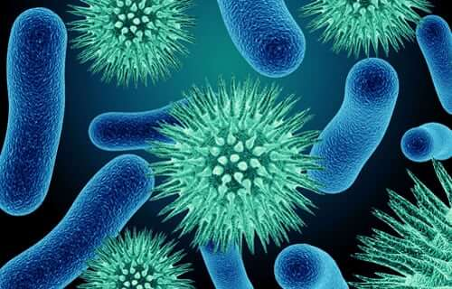

Course Start is independent learning you need to complete as a fundamental part of your introduction to the course. It should take you approximately 5 hours to complete.

|  |  |
| --- | --- |
| Course Name | **AAQ Medical Sciences** |
| How this **Course Start** fits into the first term of the course | Task 1 involves tasks which are relevant to the first assignment of Unit 3, which we start at the beginning of Term 1.  Task 2 involves tasks which are covered in Unit 1, which we start in term 1 and continue with until the exam in May. |
| How will my **Course Start** learning be used in lessons? | Task 1 could be incorporated into the first Unit 3 assignment.  Task 2 assesses knowledge of biological molecules; a strong foundation of this is needed for Unit 1. |
| **Course Start** learning objectives | To develop research skills  Assess underlying knowledge from GCSE. |
| Study Skills | * **Research**: you will be expected to find out information from reputable sources of information. * **Referencing**: you will be expected to use appropriate referencing conventions when writing up assignments. * **Summarising to consolidate:** Tabulating key facts about biological concepts is one way to review content. |

**Expectations for: AAQ Medical Science**

Our exam board is: Pearson

|  |
| --- |
| **What this course involves** |
| 5 hours independent study per week |
| Regular attendance and to be punctual to all lessons |
| Respect for all members of the college |
| To follow lab rules and be safe at all times |
| To take part in class discussions and activities |
| To be resilient and seek support when needed |
| Developing independent learning skills (e.g. time management, preparing for each week’s lessons, completing learning tasks outside lessons) |

**Task 1**:

This task is related to Unit 3, your assignment-based unit about microbiology and infectious diseases.

1. **Draw and label a bacterial pathogen that causes a specific disease.**
2. **Name the pathogen that causes the disease.**
3. **Name the disease caused by the pathogen**
4. **Find out one feature of this pathogen that makes it good at causing the disease.**

You will need to use books or a reputable website to find relevant information to help you complete your tasks – you will need to REFER to your sources of information. This is called ‘**Referencing**’.

At the bottom of your task, refer to your sources of information in the following ways. Aim to use at least one book and one internet site.

If you use a book, write out your ‘Reference’ in the following way:



If you use a website write out your ‘Reference’ in the following way (You may not be able to find the author or the year the site was created – try to include as much information as possible. At the very least, you should include the web address and the date you accessed the site)

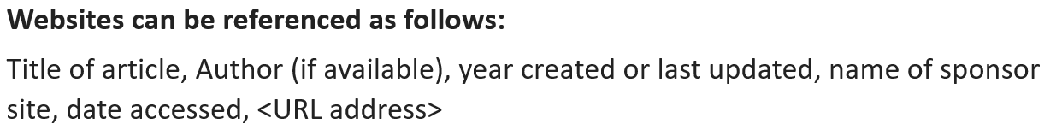

**Task 2**:

This is related to Unit 1, your exam-based unit ‘Principles of human physiology, anatomy and pathology’.

**Complete the table below using a reliable internet site or a textbook**

|  |  |  |  |  |
| --- | --- | --- | --- | --- |
| Name of biological molecule | Example | Elements present (e.g. carbon, hydrogen etc.) | Name of building blocks (monomers) | Name of bond between building blocks (and name of reaction that makes this bond) |
| Carbohydrates | Starch/ Glycogen |  |  |  |
| Proteins | Collagen |  |  |  |
| Lipids | Triglyceride |  |  |  |
| Nucleic acids | DNA, RNA |  |  |  |