**Course Start**

Course Start is independent learning you need to complete as a fundamental part of your introduction to the course.

It should take you approximately 5 hours to complete.

|  |  |
| --- | --- |
| Course Name | **Spanish IB** |
| How this **Course Start** fits into the first term of the course | **Section 1**: these reading comprehension tasks are "transitional". They intend to activate your language competence from GCSE while preparing for more "authentic" sources.  **Section 2**: it demands a reflection on your motivation to join this course and encourages you to take control of your own learning. It invites you to read an authentic article (written for "native speakers"), similar to other texts that you will be working with during this two year course.  **Section 3**: you will be completing this task during the 2nd week of the course, on your first Conversation Class.  **Sections 4 & 5**: this task is and will be very relevant THROUGHOUT your two years in this course. It invites you to put yourself in situations where you are exposed to the language you are learning during your "free time". |
| How will my **Course Start** learning be used in lessons? | Your work will be used to identify where you are in terms of language competence as well as to help us to get to know you better (reasons to join the course). Your work will be used as a "needs analysis".  Section 3 will be the introduction and main content of your first conversation class. |
| **Course Start** learning objectives | * Identify and reflect on global issues (technology addiction, environment and healthy living challenges) * Identify relevance of the course * Describe and justify personal motivations for Spanish language learning * Reflect and share the main aspects of your personal identity * Explain the main events of your holidays |
| Study Skills | * Research/ reading/summarising/ written and oral presenting |

**Expectations for: IB Spanish**

Our specification is IB Spanish

|  |
| --- |
| **What this course involves** |
| All student will have the following time in class:  **-Higher level: 3 lessons a week (2 double and 1 single), (3:45 hours)**  **-Standard level:2 lessons a week (1 double and 1 single), (2:15 hours)**  **-Everyone: 30 mins conversation in groups of two or three students**  You will be expected to work independently for:  **1.5 hrs a week (SL)**  **3 hrs a week (HL)**  Students are also encouraged to use and be exposed to the target language as much as possible (reading news, fiction or non-fiction texts, watching films, listening to podcasts or audiovisual material, writing a diary, using your phone in Spanish…) |
| **Type of activities**  We will be working with different types of texts: professionals, from media or personal.  You will work and develop all 4 main language skills: listening, reading, writing and speaking.  **Listening**: you will work with original recordings or videos and answer questions to prove detailed understanding or summing up main points.  **Reading**: you will read a wide variety of texts (press articles, blogs, interviews, reports..)  **Writing**: you will write short academic analytical texts (A Level) and a variety of other type of texts (IB) of topics related to global issues and the Spanish Speaking World  **Speaking**: you will take part and engage in class discussions and debates as well as role plays. |
| **Conversation classes**  What are they like?   * In small groups (2 or 3 students) with the language assistant * Focus on fluency * Grammar support * Exam preparation |

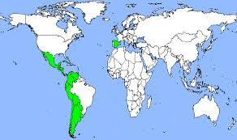

**COURSE START for IB Spanish (SL & HL)**

**Estudiantes de año uno de A Level y Bachillerato Internacional: ¡Hola a todos/as!**

Here is what I would like you to do over the summer (it should not take more than 5 hours!)

**Tiene CINCO SECCIONES:**

1. **three brief reading tasks *-must-***
2. **one brief writing task *-must-***
3. **prepare a short oral presentation *-must-***
4. **(Opcional) escritura sobre..(recomendado) *-should-***
5. **(Opcional) lectura -"Un día en…" (recomendado) *-could-***

**PARTE 1 *-must-***

* **Texto A (Tecnología-Videojuegos)**

*Read the following text and then answer the questions IN SPANISH*

|  |
| --- |
| 1. What do Spanish adolescents like to do in their spare time? 2. How often do they play video games? 3. Do video games have the same popularity among boys and girls? 4. What are the main consequences of spending a lot of time playing video games? |
| ***Write your answers here*:** |

* **Texto B (Salud / *Health)***

*Read the following text and then answer the questions IN SPANISH*

|  |
| --- |
| 1. What is the main health issue nowadays with young people? 2. How can this affect people’s health? 3. What pieces of advice are given by Dr. Koller in the text? |
| ***Write your answers here*:** |

* **Texto C (Medioambiente / *Environment )***

*Read the following text and then answer the questions IN SPANISH*

|  |
| --- |
|  |
| 1. Why is the Amazon rainforest in danger? 2. Name the main threats. 3. Why is the Amazon rainforest important? |
| ***Write your answers here*:** |

**PARTE 2 *-must-***

*Read the following text and then answer the question IN SPANISH.*

*You should write between 100 and 200 words*.

|  |
| --- |
| Read the following [**article**](https://dublin.cervantes.es/es/cursos_espanol/razones_estudiar_espanol.htm#:~:text=El%20espa%C3%B1ol%20te%20permite%20viajar,necesaria%20en%20todos%20los%20%C3%A1mbitos.)in Spanish (you can use a dictionary, of course, but you do not need to understand every single word) and then write a paragraph addressing the following points.  Check if the 7 main points stated in the texts are relevant for your motivation for learning Spanish.   * **And why are you studying Spanish?**   **Ejemplo:** yo estudio español porque … y para …   * **Do many people in your country study Spanish? and other languages?** |
| ***Write here...*** |

**PARTE 3 *-must-***

As you know, all of you will be having Conversation classes (CdC) every week (in pairs).

On your first session (week 2) you should be ready to:

* Ask and answer questions on Personal Information (name, age, where you live, hobbies, school, family and friends…)
* Talk about your summer holidays

**PARTE 4 (Opcional) *-should-***

A few more options if you feel like using your Spanish even more before our first lesson in September.

**Opción A:**

Elige una producción audiovisual de ficción (**película o serie**) ambientada en el Mundo Hispano (España o Latinoamérica) y escribe una reseña o entrada de blog. Puedes incluir:

* + breve resumen del argumento
  + Información técnica (director/a, actores/actrices, año….)
  + relevancia / impacto (datos de popularidad)
  + visión personal
  + …

(No escribas menos de 200 palabras ni más de 600).

**Opción B:**

Elige un trabajo musical (**una canción, un álbum, un concierto**…) de algún artista conectado con el Mundo Hispano y escribe una reseña (más formal) o entrada de blog (menos formal).

**Opción C:**

Elige una obra de arte (**pintura, exposición**…) de algún artista conectado con el Mundo Hispano y escribe una reseña (más formal) o entrada de blog (menos formal).

**PARTE 5 *-could-***

* Lee alguno de los libros escaneados y compartidos en nuestro GC (**sección A1**: Lecturas graduadas)

(Aventura en La Habana, Objetivos Barcelona, Perdidos en el Camino, Persecución en Madrid)

***I hope you enjoy your well deserved summer break and I am looking forward to working with you all in September!***

**Please type your Flying Start work on a Google Doc and get it ready by the 9th of September.**

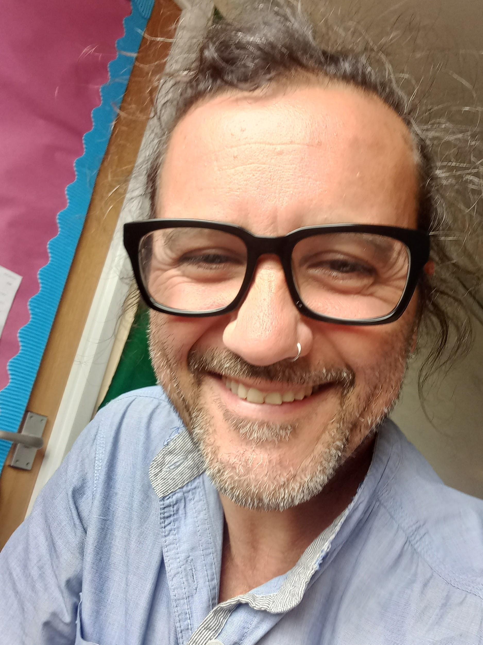 ***¡Buenas vacaciones!***

**Ramon**