Course Start

Course Start is independent learning you need to complete as a fundamental part of your introduction to the course. It should take you approximately 5 hours to complete.

|  |  |
| --- | --- |
| Course Name | Modern History A level |
| How this Course Start fits into the first term of the course | This induction will begin to look at the nature of history. What do we mean by history? What is the role of a historian?  We will begin to consider some of the depth studies which will be relevant later in the course, such as China, giving you a better understanding of the period.  In addition we will consider the nature of revolutions throughout history and their consequences.  Finally we will consider the idea of interpretations, where do historians' views come from, and why do they differ? |
| How will my Course  Start learning be used in lessons? | This will be linked directly to your first week of teaching, and referred back to as we begin China and your coursework. |
| Course Start learning objectives | * Understanding key concepts in History e.g. causes, consequence, turning points, significance, change & continuity, interpretations * Understanding chronology & significance of events for one of your Y1 Papers * Developing appropriate study skills for A Level History |
| Study Skills | * Independent research * Conceptual thinking * Developing your own ideas & opinions |

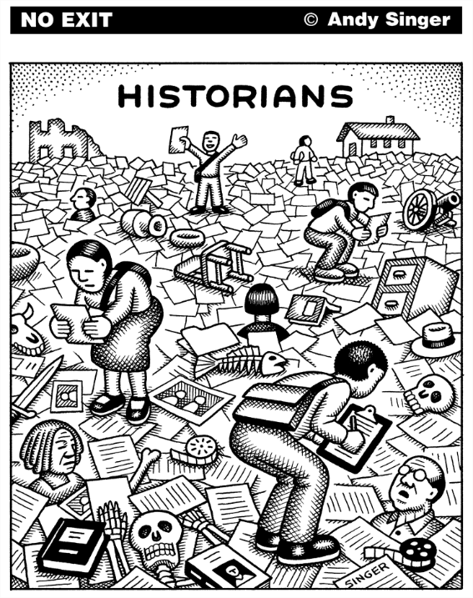

Hello! Welcome to Varndean College History Department – we are history obsessives & have put together a course that we think you will find rewarding, engaging, challenging, maybe even inspiring.

To help you feel confident and ready for A Level Early Modern History, we’ve put together some activities to introduce you to key concepts from the course including causation and impact; change and continuity; historians’ perspectives. We hope that these will also help you to reflect on the nature of History as an academic discipline, and patterns that we can observe in events that happened in vastly different times and places.

1. What is History?
2. Talking about a revolution
3. Case study: twentieth-century China

We suggest that you do these tasks in 2 or 3 sessions over the summer - don’t try and do them all in one go! You must work through all 3 tasks (and you should do all of the questions in each section):

You could also delve deeper into the past by following up some of the suggested links or dipping into anything that catches your eye from the reading list.

We’re looking forward to meeting you soon. We’ve included some course details and FAQ at the end of this document, but if you have any other questions or concerns, do drop us an email.

Ruth Kelly (Programme Leader, History) - [rak@varndean.ac.uk](mailto:rak@varndean.ac.uk)

Martin Ballard (History Tutor) - [mrb@varndean.ac.uk](mailto:mrb@varndean.ac.uk)

Kate Wall (History Tutor) - [kmw@varndean.ac.uk](mailto:kmw@varndean.ac.uk)

Marta Baranska (History Tutor) - [mzb@varndean.ac.uk](mailto:mzb@varndean.ac.uk)

1. **Read the article and answer the question at the end!**

# *What is the point of history?*

*Does historical research get us closer to ‘the truth’ of past events? And how does that help you in today’s society?*

*History does not have lessons. This may come as a surprise, as it is common to hear people talking about learning ‘the lessons’ of the past or claiming that ‘history is on my side’, but I think it is true. If historical events carry simple lessons, it suggests that the same actions will always have the same result. But they do not. Just because one coup attempt fails, it does not mean that all coup attempts are futile. The fact that one invasion of a country succeeded does not mean that other attempts will also succeed. The fact that one set of circumstances produced a dictatorship does not mean that similar circumstances will always do the same. Every disastrous or failed development in human history has had its supporters claiming that it has ‘history on its side’, or that its opponents will end up in the ‘dustbin of history’. History is many things, but it is not a dustbin.*

*Interpreting the past*

*History is primarily a method of disciplined understanding, and its underlying principle is a respect for the truth. When historians come up with a new way of interpreting the past – one which challenges and changes the way we have understood it hitherto – they are not doing it to be contrary or to fulfil a whim. Rather, they do it because in some way they think their new thinking gets us closer to the truth.*

*It may be a question of correcting a misunderstanding; it may be a different way of interpreting familiar events; it may be more a question of adding different perspectives into the picture – for example, women, children, environmental issues, disability – in order to get to a fuller understanding of what happened; or it may be the addition of new evidence that has recently come to light. Whichever one of these applies, the result is a more accurate understanding of the past than the one we had before. We are closer to the truth.*

*Historical truth*

*Talk of historical truth can take us into deep philosophical water. What is ‘truth’? What might ‘the truth’ look like in historical terms? Is there such a thing, indeed? Is it possible to construct in every single detail, in terms of your thoughts and feelings as well as your actions, big and small, a ‘complete truth’ of even a single day in your own life? If that is almost impossible, how much harder is it to do something similar for major historical events or movements? Nevertheless, that is what historians do – they try to get closer to this notional ‘truth’ by adding to or altering existing historical knowledge and understanding.*

*Truth and society*

*No doubt this will seem all very well, but you might think it’s not going to help you much in a job interview if you are asked the point of your having studied history. But if you think that, think again. There are plenty of areas of work that seek to identify the truth – police and judicial work are obvious examples, but it is also true of many types of work, including journalism, science, social work, marketing, administration and government. The film director Ridley Scott recently defended his film Napoleon against historians criticising its inaccuracies by asking historians the arguably fatuous question, ‘How do you know? Were you there?’ The answer to his question, of course, is that historians study in close detail the evidence left behind, from which we can work out the truth of what happened and we can also denounce false claims. The ability to find out the truth is often lacking in life and is always needed.*

*Think for a moment of the implications of Scott’s question. If we hold to the idea that ‘If you weren’t there, you can’t know’, then anyone can come up with any idea, however crazy or offensive and dangerous and claim it as ‘true’. If we start believing that everyone’s own view is their ‘truth’, then we cannot challenge even deliberate lies and falsehood. Conspiracy theorists or Holocaust deniers routinely make sweeping claims without a shred of evidence, but will come up with ever more outlandish analysis to undermine clear evidence that contradicts them. In the end, a society that has ceased to care about truth, or about whether people’s claims can be substantiated, has no defence against those who live by lies. Such people rarely intend good to others.*

*So, study history because you enjoy it, or because you learn to analyse and argue, or because you want it to open careers to you – all of these are valid and good reasons. But the real importance of studying history lies much deeper: free study of the past is an unmistakable sign of a society committed to truth, and ultimately such societies offer more freedom and justice than those which are not.*

*The Royal Historical Society has recently published a report, ‘The Value of History in UK Higher Education and Society’, which is accessible to all at:* [*https://tinyurl.com/jezw4wwa*](https://tinyurl.com/jezw4wwa)*.*

Task: In 300 words, explain what history means to you. Why have you chosen to study it? What do you want to gain from it?

On the A Level Early Modern History course you’ll be studying historical developments in different regions of the world, including Britain & France.

One theme common to all of the regions that we study is that of [**revolution**](https://dictionary.cambridge.org/dictionary/english/revolution)**.**

**Task 2b: Define REVOLUTION in a sentence, or create a spider diagram showing its meaning.**

**Task 2b: Read the article and answer the questions at the end (1.5 hours)**

*Nicholas II and the Russian people*

*1 Study Source A. What does this image of the tsar indicate about his views on his own role and the place of progress and modernisation in Russia?*

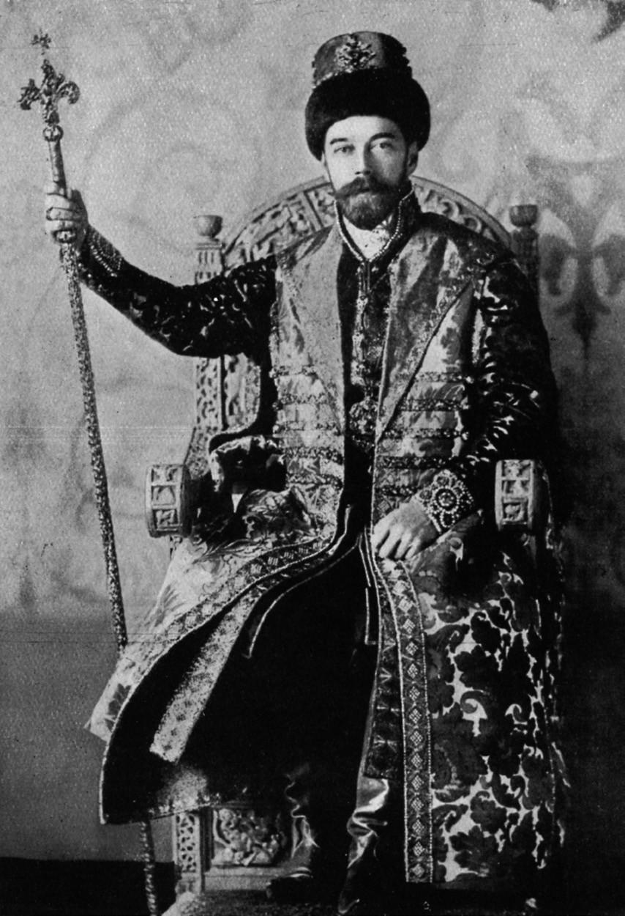

*Source A Nicholas II dressed as a medieval Russian tsar*

*2 Study Sources A and B. What impression do they give about divisions within Russian society?*

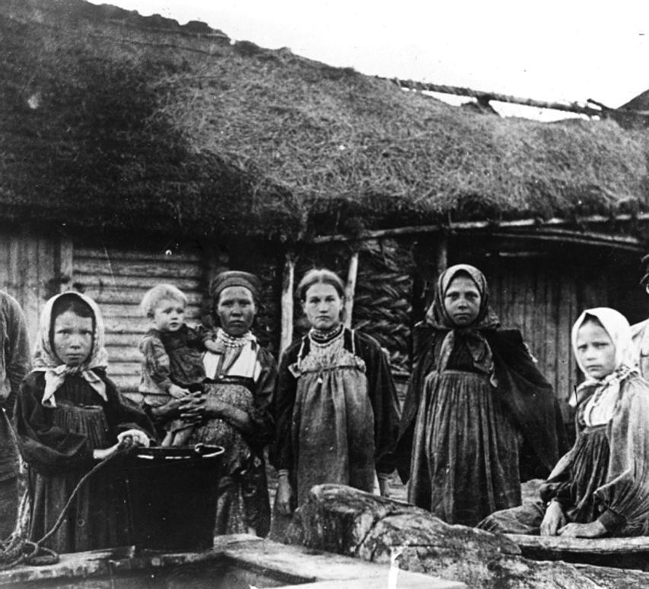

***Source B Russian peasant women, c. 1905***

*In the two decades before the Russian revolutions of 1917, Russian society underwent a series of dramatic transformations which would have presented even a competent ruler with immense challenges. A combination of a deliberately rigid and inflexible system, ill designed to absorb the social tensions created by a changing economy, and a weak and ineffectual ruler led Russia to a period of crisis between 1902 and 1907. However, it was the pressures of war that finally led to the regime’s overthrow.*

*Throughout the nineteenth century there had been attempts to reform Russia in order to ensure tsarism’s continued survival. Tsar Alexander II initiated the emancipation of Russia’s serfs after 1861, fearing that unless reform came from above, it would eventually ‘come from below’. The failure of these reforms led to Russia’s now legally free peasantry being burdened with decades of debt. Their anger and resentment towards Russia’s landowning classes and the state would explode into violence under the reign of Alexander II’s grandson.*

***A reluctant tsar***

*Nicholas II came to the throne in 1894. He was a reluctant tsar — he broke down in tears on hearing that he had inherited the autocracy. A devout Russian Orthodox Christian, Nicholas believed that he had been chosen to be tsar by God, and that no matter how difficult or unpleasant the task, it was not a role that he could set aside — in his view, one did not simply ignore God’s instructions. He combined this dogmatic belief with a crippling shyness and an indecisive nature, both products of a childhood spent in the shadow of his bullying and domineering father Alexander III.*

*Nicholas ruled over the Russian empire, aided by its fundamental laws, which granted him almost unlimited power. He was the singular source of legal authority in the empire and, crucially, he was not obliged to listen to advice. The tsar’s ministers could be dismissed if they displeased and they could be ignored with impunity if the tsar felt so inclined.*

*It was remarked on that Nicholas was a caring father and family man, but here was where his talents ended. He spent a great deal of time focusing on trivial matters and ignored the serious economic, social and diplomatic issues facing the country. Ministers recount stories of the tsar finding official matters boring and tiresome and his attention span waning as meetings progressed.*

*Nicholas failed to appreciate that change was coming to Russia whether he liked it or not. Technological changes such as rail, telecommunications, the internal combustion engine and electric light were transforming cities and beginning to penetrate the countryside. This meant that the experience of ordinary Russians was starting to change.*

***Peasants***

*Patterns of work, social life and commerce that had remained unchanged for centuries were beginning to be disrupted. Influxes of Russian peasants into the cities to join the ranks of the developing Russian working class were one example of this. Many Russian peasant men shed the traditional ways of the peasants, shaving off their beards and abandoning rural superstition to embrace the modern world of work and, in some cases, education.*

*The tsar was reluctant to see the peasants as anything other than loyal and obedient subjects. He had few encounters with the peasantry that were not stage managed to give the tsar the impression of a kindly and peaceful rural people immersed in tradition and Russian Orthodoxy. The reality was that peasant life expectancy was short, life in peasant communes was often violent and alcoholism was a huge problem. Far more serious than this, however, was the peasants’ hunger for land and the violence they would resort to in order to seize it from the nobility when order broke down in Russia.*

***Middle classes***

*If the tsar loved the peasants, the same cannot be said for the emerging middle classes of Russia. Nicholas II viewed the new urban and provincial bourgeoisie with immense suspicion and resented the powers that his grandfather Alexander II had given local government in the 1860s. Across Russia, local government organisations — the Zemstva — had been established. These were normally run by the concerned and educated middle classes and were comprised of doctors, agronomists, engineers and liberal-minded aristocrats. Their view was that to be a patriotic Russian, one must care for and try to help the poorest Russians.*

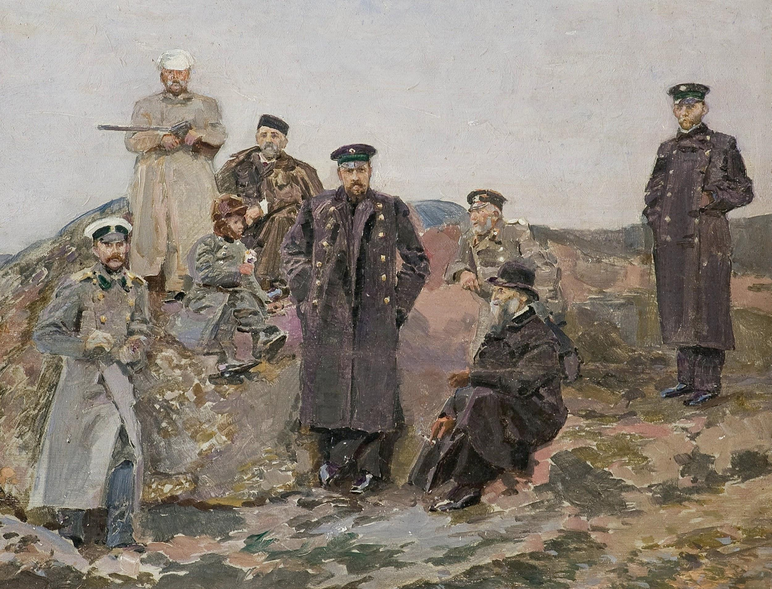

***Source C Sergei Witte with railway engineers***

*The tsar believed that this was his role too, but he was rarely capable of fulfilling it. This had been the case under the tsar’s father who in 1891 had mismanaged a famine in the Volga region disastrously, leaving hundreds of thousands of Russian peasants to die of starvation and disease. It was the Zemstva that stepped in to distribute food and medicine and who quickly came to see the government not just as incompetent but as illegitimate. Their view was that any government that could not feed and protect its own people from harm had little right to rule.*

***Slavophilism vs modernisation***

*Nicholas’s childhood mentor had been the religious conservative Konstantin Pobedonostsev, who had cultivated in the tsar a scepticism of modern ideas and change. The two men were part of a cultural and intellectual movement in Russia known as Slavophilism. The more conservative Slavophiles believed that Russians must look to their past and to Russian traditions for answers to their problems in the present. New ideas, particularly those that came from Western Europe, were dangerous and should be resisted.*

*However, in the late nineteenth century, holding back the flow of ideas and scientific knowledge that was moving across the world with ever greater rapidity was all but impossible. Mass printing, growing literacy and the introduction of telegraphy and railways into Russia meant that within a generation ideas from Charles Darwin to Karl Marx had penetrated urban and rural Russia to a degree that would have been unthinkable half a century earlier.*

***Economics and foreign capital***

*Nicholas had little understanding of economics and the one minister who did, Sergei Witte, was viewed by the tsar with suspicion. Witte was a moderniser who used state investment to build Russia’s railways. He knew also that much of the world was being rapidly transformed through foreign investment.*

*Witte arranged for Russia to join the Gold Standard, the fixed exchange rate mechanism that managed the value of European and US currencies. This meant that flows of foreign capital could now pour into Russia, purchasing raw materials and creating the funds to build factories and infrastructure. It also meant that Russia, which had previously been insulated from the world economy, was now forced to operate by its rules. Economic booms and busts had a more pronounced effect on Russian society after the adoption of the Gold Standard.*

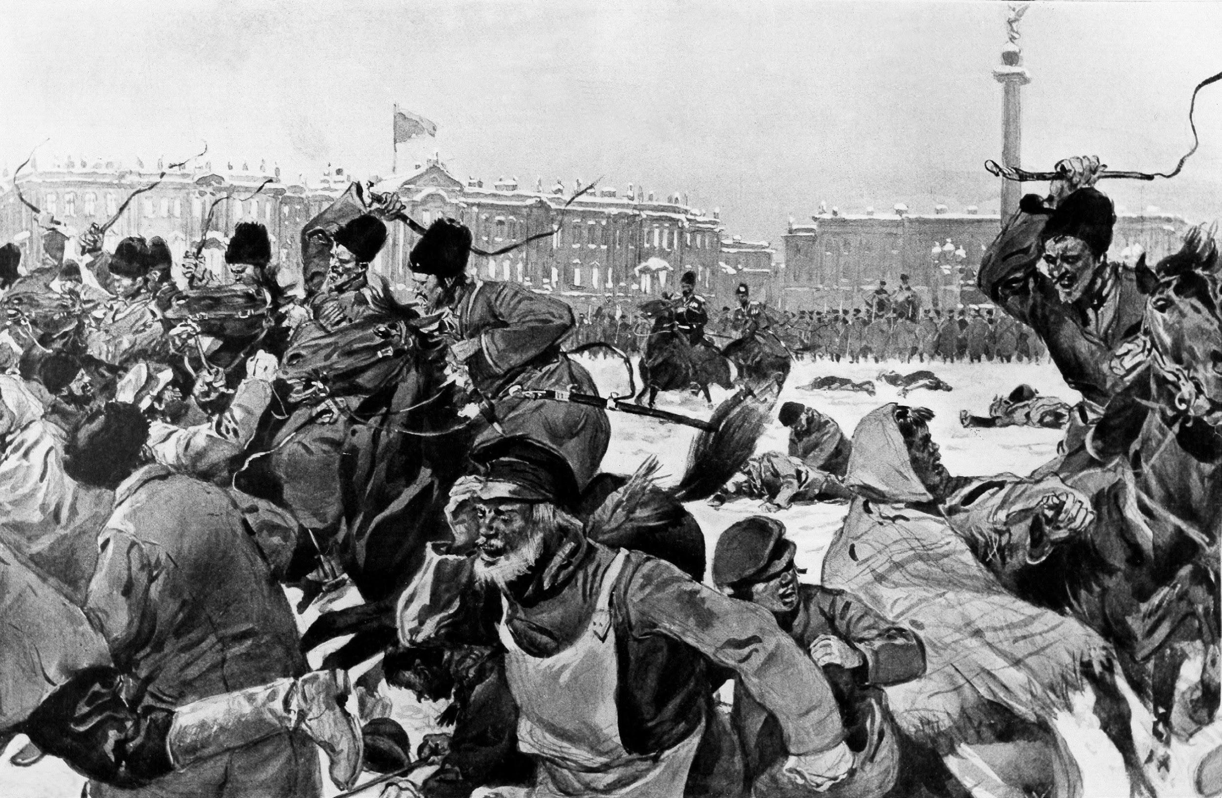

***Source D The Bloody Sunday massacre in St Petersburg in January 1905***

***Source E***

*An account of the Bloody Sunday (Nicholas II and the Russian people) massacre in St Petersburg in January 1905 by US diplomat Robert McCormick:*

*“In all the years (eighteen) I have spent in Russia, I never knew the Russian public to be so united as in their views in connection with the action of the authorities in ordering the soldiers to shoot the workmen, their wives, children and harmless spectators last Sunday in St Petersburg. All classes condemn the authorities and more particularly the Emperor. The present ruler has lost absolutely the affection of the Russian people, and whatever the future may have in store for the dynasty, the present Czar will never again be safe in the midst of his people…”*

***Growing unrest***

*Between 1902 and 1904 there had been mounting unrest as an angry and resentful peasantry, a working class that increasingly refused to accept its appalling living conditions and an alienated middle-class intelligentsia saw the regime as the source of all their problems. When troops massacred working-class demonstrators in St Petersburg in January 1905, the country exploded into open revolution.*

*The crew of the tsar’s flagship, the Potemkin, mutinied in the Black Sea and sailed to Romania and freedom and rail strikes saw the tsar trapped in his Peterhof Estate. Even in the middle of crisis, it was only the marginalised progressive Sergei Witte who really understood the tsar’s predicament and presented him with a credible solution. Nicholas II was adamant that it was the people who needed to demonstrate that they were worthy of him, not the other way round.*

***Source F:******Extracts from the October Manifesto of 1905 issued by Nicholas II:***

*“The disturbances and unrest in St Petersburg, Moscow and in many other parts of our Empire have filled Our heart with great and profound sorrow… The oath which We took as Tsar compels Us to use all Our strength, intelligence and power to put a speedy end to this unrest which is so dangerous for the State…*

*We have therefore ordered the government to take the following measures in fulfilment of our unbending will:*

*1. Fundamental civil freedoms will be granted to the population…*

*2. Participation in the Duma will be granted to those classes of the population which are at present deprived of voting powers…*

*3. It is established as an unshakeable rule that no law can come into force without its approval by the State Duma…”*

***The October Manifesto and the duma***

*After a century of the gradual erosion of autocratic power throughout Europe as a result of revolutions and progressive constitutions, Russian autocracy was almost entirely unreformed and 1905 represents a great missed opportunity to save the regime. Witte encouraged the tsar to sign the October Manifesto, a constitutional settlement with Russia’s people.*

*The manifesto offered limited constitutional reform in the guise of a duma (a parliament), and the abolition of peasant debt. It was designed to divide the peasants, the workers and the middle classes, preventing them from being a united force against the tsar. The manifesto and extensive state repression succeeded in saving the regime, but the tsar cursed Sergei Witte’s name thereafter.*

***Stolypin***

*This extraordinary response to the salvation of the tsar’s rule is easy to explain once the mentality of Nicholas II is born in mind. He believed that God alone had the right to give him power and take it away and it was not for the people to decide the extent of the tsar’s rule in Russia. Nicholas was determined to undermine the duma and the appointment of Pyotr Stolypin as the tsar’s prime minister in 1906 helped to achieve this.*

*Stolypin, a conservative, dissolved the second duma in 1907 and then altered constitutional law to ensure that the third duma was filled not with workers’ representatives but those of the nobility and the reactionary right. In doing so he signalled to the opponents of the tsar that Nicholas would never keep his promises and could never be trusted. It was this demonstration of his capacity for bad faith that would contribute to the tsar’s eventual overthrow in February 1917. HS*

**Task: now answer these questions**

### 1. Why was Nicholas II's personality and upbringing a key factor in his failure to respond effectively to the challenges facing Russia between 1894 and 1907?

### 2. In what ways did the relationship between the Russian state and the peasantry differ from the tsar's perception of it, and why did this misunderstanding matter?

### 3. How did Nicholas II's views on modernisation and Slavophilism shape his attitudes toward reforms, and what consequences did this have for Russian society?

### 4. What role did Sergei Witte play in both the modernisation of Russia and the survival of the tsarist regime during the 1905 crisis, and how was he subsequently treated by Nicholas II?

### 5. How did the events and aftermath of Bloody Sunday illustrate growing unity among Russia’s social classes against Nicholas II, and what effect did this have on his authority?

**3. Case study: twentieth-century China (3 - 4 hours)**

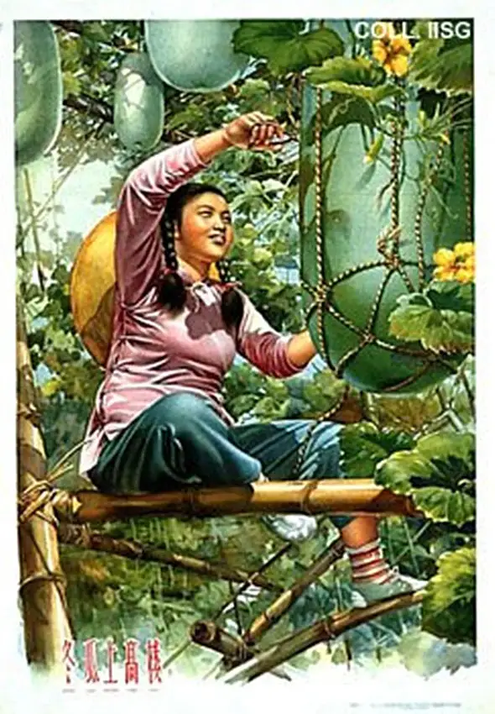

As we have seen, China was subject to huge changes in the twentieth century, experiencing several revolutions including in 1911, 1949 and 1966-76.

Must do:

1. Watch: documentary [This documentary on Mao Zedong](https://www.youtube.com/watch?v=ewXLOSEeyKA). Note down dates of key events in twentieth-century China.
2. Read: [article by Michael Lynch - Mao: Liberator or Oppressor?](https://drive.google.com/open?id=1WNlTLUETU7gECg_kO57m-Lonf_tEhHou)
3. Create: a timeline showing 10 key events that you identify as being important to twentieth-century China. You must include at least one event from before 1920, and at least one from after 1976.

You should:

* include a brief explanatory sentence about each event, and / or illustrate them with images or symbols
* think carefully about Lynch’s article and try to identify what arguments he puts forward about Mao Zedong. Is his portrayal negative, positive or a mixture?

You could:

* choose to present your work in a creative way - PowerPoint presentation, podcast, video or Ted talk.
* use [Chinese Revolution](https://alphahistory.com/chineserevolution/) to find out more about any events or people who you’ve found interesting.
* read [Frank Dikötter’s article on the Cultural Revolution.](https://drive.google.com/file/d/1mwfJz3N7G1UFFxnJ_X--DJJ8B6P16B7m/view?usp=sharing)

****************************************************

**A Level Modern History: Course information & FAQs**

|  |  |  |
| --- | --- | --- |
| **Unit/Paper** | **% of 2 year course** | **Structure & assessment** |
| Paper 1 Russia 1917-91: from Lenin to Yeltzin | 30 | * Section A: essay (c.10 years) * Section B: essay (c.20 years, or 1917-85) * Section C: essay on interpretations of 1985-91 |
| Paper 2: Mao’s China 1949-76 | 20 | * Section A: contemporary source evaluation * Section B: essay |
| Paper 3: Protest, agitation & parliamentary reform, Britain c.1790-1928 | 30 | * Section A: contemporary source evaluation (context = 1 of 5 depth studies) * Section B: essay on 1 of 5 depth studies * Section C: essay on change over 100 years |
| Paper 4: Historical Investigation | 20 | * 4000 word essay investigating & evaluating different historical interpretations |

**Do I need a textbook?**

|  |  |
| --- | --- |
| The main text we recommend is not the official Pearson Edexcel exam board one but this - [Communist States in the 20th Century](https://www.amazon.co.uk/History-Edexcel-Level-Communist-twentieth/dp/1471837912/ref=sr_1_1?crid=3OP0N86JO7WX2&keywords=robin+bunce&qid=1585482163&s=books&sprefix=Robin+Bunce%2Caps%2C142&sr=1-1).  This is by Robin Bunce, Peter Clements & Andrew Flint, Hodder Education, (2015), ISBN 1471837912  We suggest that students have their own copy to assist with homework & revision, but we don't normally require them to bring it to class as our teaching makes use of a whole range of other resources & strategies including non-public online archives that students access via the college library VLE. |  |

**What else do I need?**

You will need to bring a ring binder with dividers, some A4 lined paper, a pen, pencil and a highlighter. Coloured pens also come in handy!

**How much homework/independent study will I get?**

About five hours of ‘planned study’ per week.  This could be research, preparing for a group discussion or presentation, writing an essay, or revising for a timed essay or quiz.

**What trips are planned?**

This year we took part in the New York & Washington trip with the Politics Department, & we ran a research & using sources workshop using the Mass Observation Archive at Sussex University’s ‘The Keep’. In recent years we have also been to Edinburgh & the National Gallery in London. We hope to offer similar opportunities in the future.

We’re really looking forward to meeting you - have a great summer and see you soon!

Any other questions? Drop us an email :)

Ruth Kelly - rak@varndean.ac.uk

**A level Modern History: course content**

**Paper 1 Russia 1917-91**

* Communist government inc. Stalinism
* Industrial & agricultural change inc 5 Year Plans
* Control of the people e.g. use of secret police, state control of culture
* Social developments e.g. education, communal housing
* Evaluating interpretations on the debates about the collapse of USSR 1985-91
* The significance of the economic weaknesses of the USSR and the failure of reform.
* The effects of Gorbachev’s failure to reform the Communist Party and the Soviet government.

**Paper 2 Mao’s China 1949-76**

* Establishing communist rule 1949-57 inc. the development of Maoism
* Agriculture & industry 1949-65 in. the Great Leap Forward
* The Cultural Revolution & its aftermath 1966-76
* Social & cultural changes 1949-76 e.g. religion, the lives of women

**Reading List**

**Paper 1 Russia 1917-91**

* Orlando Figes, *Revolutionary Russia 1891-1991*, Pelican, 2014
* Robert Service, *The Penguin History of Modern Russia: From Tsarism to the Twenty-first Century*, Penguin, 2015

**Paper 2 Mao’s China 1949-76**

* Jung Chang, *Wild Swans* (Harper Collins 1991) excellent background and a gripping read: highly recommended
* Jung Chang & Jon Halliday, *Mao – The Unknown Story* (Vintage, 2006)
* Frank Dikotter on C20th dictators:
* <https://www.historyextra.com/period/20th-century/dictators-explained/>
* Julia Lovell on Maoism: <https://www.historyextra.com/period/20th-century/maoism-who-was-mao-communist-leader-china-ideology-cundill-history-prize/>
* Michael Lynch, *The People’s Republic of China since 1949*, (Access to History – 2008). Good A-level text if you want a bit more depth on a particular topic; useful for essays. Lots of copies in the college library.