**Course Start**

Course Start is independent learning you need to complete as a fundamental part of your introduction to the course. It should take you approximately 5 hours to complete.

|  |  |
| --- | --- |
| Course Name | **Early Modern History** |
| How this **Course Start** fits into the first term of the course | This induction will begin to look at the nature of history.  What do we mean by history? What is the role of the historian?  We will begin to consider some of the depth studies which will be relevant later in the course, such as 17th century Britain, giving you a better understanding of the period.  In addition we will consider the nature of revolutions throughout history and their consequences.  Finally, we will consider the idea of interpretations, where do historians’ views come from, and why do they differ? |
| How will my **Course**  **Start** learning be used in lessons? | This will be linked directly to your first week of teaching, and referred back to as part of both Paper 1 (Britain) and Paper 2 (France) |
| **Course Start** learning objectives | * Understanding key concepts in History e.g. causes,consequence, turning points, significance, change & continuity, interpretations * Understanding chronology & significance of events for one of your Y1 Papers * Developing appropriate study skills for A Level History |
| Study Skills | * Independent research * Conceptual thinking * Developing your own ideas & opinions |

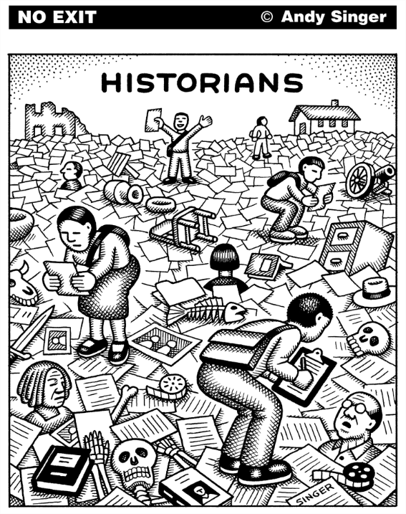

Hello! Welcome to Varndean College History Department – we are history obsessives & have put together a course that we think you will find rewarding, engaging, challenging, maybe even inspiring.

To help you feel confident and ready for A Level Early Modern History, we’ve put together some activities to introduce you to key concepts from the course including causation and impact; change and continuity; historians’ perspectives. We hope that these will also help you to reflect on the nature of History as an academic discipline, and patterns that we can observe in events that happened in vastly different times and places.

1. **What is History?**
2. **Talking about a revolution**
3. **Case study: seventeenth century Britain**

We suggest that you do these tasks in 2 or 3 sessions over the summer - don’t try and do them all in one go!

You **must** work through all 3 tasks (and you **should** do all of the questions in each section).

You **could** also delve deeper into the past by following up some of the suggested links or dipping into anything that catches your eye from the reading list.

We’re looking forward to meeting you soon. We’ve included some course details and FAQ at the end of this document, but If you have any other questions or concerns, do drop us an email.

**Ruth Kelly (Programme Leader, History)**

[rak@varndean.ac.uk](mailto:rak@varndean.ac.uk)

1. **Read the article and answer the question at the end!**

# *What is the point of history?*

*Does historical research get us closer to ‘the truth’ of past events? And how does that help you in today’s society?*

*History does not have lessons. This may come as a surprise, as it is common to hear people talking about learning ‘the lessons’ of the past or claiming that ‘history is on my side’, but I think it is true. If historical events carry simple lessons, it suggests that the same actions will always have the same result. But they do not. Just because one coup attempt fails, it does not mean that all coup attempts are futile. The fact that one invasion of a country succeeded does not mean that other attempts will also succeed. The fact that one set of circumstances produced a dictatorship does not mean that similar circumstances will always do the same. Every disastrous or failed development in human history has had its supporters claiming that it has ‘history on its side’, or that its opponents will end up in the ‘dustbin of history’. History is many things, but it is not a dustbin.*

*Interpreting the past*

*History is primarily a method of disciplined understanding, and its underlying principle is a respect for the truth. When historians come up with a new way of interpreting the past – one which challenges and changes the way we have understood it hitherto – they are not doing it to be contrary or to fulfil a whim. Rather, they do it because in some way they think their new thinking gets us closer to the truth.*

*It may be a question of correcting a misunderstanding; it may be a different way of interpreting familiar events; it may be more a question of adding different perspectives into the picture – for example, women, children, environmental issues, disability – in order to get to a fuller understanding of what happened; or it may be the addition of new evidence that has recently come to light. Whichever one of these applies, the result is a more accurate understanding of the past than the one we had before. We are closer to the truth.*

*Historical truth*

*Talk of historical truth can take us into deep philosophical water. What is ‘truth’? What might ‘the truth’ look like in historical terms? Is there such a thing, indeed? Is it possible to construct in every single detail, in terms of your thoughts and feelings as well as your actions, big and small, a ‘complete truth’ of even a single day in your own life? If that is almost impossible, how much harder is it to do something similar for major historical events or movements? Nevertheless, that is what historians do – they try to get closer to this notional ‘truth’ by adding to or altering existing historical knowledge and understanding.*

*Truth and society*

*No doubt this will seem all very well, but you might think it’s not going to help you much in a job interview if you are asked the point of your having studied history. But if you think that, think again. There are plenty of areas of work that seek to identify the truth – police and judicial work are obvious examples, but it is also true of many types of work, including journalism, science, social work, marketing, administration and government. The film director Ridley Scott recently defended his film Napoleon against historians criticising its inaccuracies by asking historians the arguably fatuous question, ‘How do you know? Were you there?’ The answer to his question, of course, is that historians study in close detail the evidence left behind, from which we can work out the truth of what happened and we can also denounce false claims. The ability to find out the truth is often lacking in life and is always needed.*

*Think for a moment of the implications of Scott’s question. If we hold to the idea that ‘If you weren’t there, you can’t know’, then anyone can come up with any idea, however crazy or offensive and dangerous and claim it as ‘true’. If we start believing that everyone’s own view is their ‘truth’, then we cannot challenge even deliberate lies and falsehood. Conspiracy theorists or Holocaust deniers routinely make sweeping claims without a shred of evidence, but will come up with ever more outlandish analysis to undermine clear evidence that contradicts them. In the end, a society that has ceased to care about truth, or about whether people’s claims can be substantiated, has no defence against those who live by lies. Such people rarely intend good to others.*

*So, study history because you enjoy it, or because you learn to analyse and argue, or because you want it to open careers to you – all of these are valid and good reasons. But the real importance of studying history lies much deeper: free study of the past is an unmistakable sign of a society committed to truth, and ultimately such societies offer more freedom and justice than those which are not.*

*The Royal Historical Society has recently published a report, ‘The Value of History in UK Higher Education and Society’, which is accessible to all at:* [*https://tinyurl.com/jezw4wwa*](https://tinyurl.com/jezw4wwa)*.*

Task: In 300 words, explain what history means to you. Why have you chosen to study it? What do you want to gain from it?

**Talking About A Revolution (Must do: 2-3 hours)** 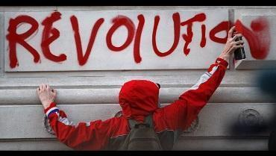

On the A Level Early Modern History course you’ll be studying historical developments in different regions of the world, including Britain & France.

One theme common to all of the regions that we study is that of [**revolution**](https://dictionary.cambridge.org/dictionary/english/revolution)**.**

**2a) Define REVOLUTION in a sentence, or create a spider diagram showing its meaning.**

**2b) Read the article and answer the questions at the end**

*The English civil wars began in 1642 and ended, 7 years later, with the execution of King Charles I and the abolition of such traditional institutions of government as the House of Lords, Star Chamber, bishops and the church courts. These unprecedented events were accompanied by an almost complete breakdown of censorship. People were free to express beliefs for which, only a few years earlier, they would have been punished with imprisonment, physical mutilation or even death. Greater freedom allowed new political movements to grow. The best known were the Levellers and Diggers.*

***Levellers and ‘true Levellers’***

***Levellers***

*The Levellers were a group of political activists and writers who came to prominence at the end of the First Civil War in 1646. They gained support from within the City of London and the ranks of the New Model Army. Levellers demanded that, out of the chaos and bloodshed of the wars, there should come a new political order which would recognise the equality of all Englishmen.*

*Their leader, John Lilburne, argued that everyone had been created equally by God and, therefore, it was wrong for anyone to have power over others except by popular consent — that is, by election. He called for the right to vote to be extended to all male heads of household (others went further to demand universal suffrage for all men, and a few even argued for the vote to be given to women), and for elections to be held every one to two years to ensure MPs were responsive to the people’s will.*

*“First Civil War There were three English civil wars. The first (1642–46) ended with Parliament’s victory and Charles I’s imprisonment. The second (1648–49) began when Charles signed a secret agreement with the Scots. This led to a Scottish invasion of England which, in turn, triggered royalist uprisings in Wales and parts of England. The third (1649–51) involved royalist attempts to put Charles II on the throne following his father’s execution.”*

***Diggers***

*The Diggers, a much smaller movement led by Gerrard Winstanley, went further and demanded not just greater political freedom, but complete economic equality too. Winstanley believed that people would not truly be free until private property had been abolished and the land shared out to everyone equally. These self-styled ‘true Levellers’ went beyond arguing their case to take matters directly into their own hands. They took up their spades and took over private land, which they cultivated and used to establish colonies, hence their name ‘Diggers’.*

***Left-wing heroes***

*Civil war radicals have been celebrated by leftwing writers and politicians. Winstanley was commemorated in the Soviet Union as a communist hero. In Britain, the early twentieth-century socialist writer and historian Henry Brailsford described the Levellers as ‘dynamic pioneers’ whose campaigns anticipated many of the most important social and political reforms of the next three centuries; and the left-wing Labour MP, Tony Benn, praised their courageous campaigns for free speech, democracy and equality.*

*It is easy to understand why these seventeenthcentury movements would appeal to modern-day socialists. When Leveller Thomas Rainsborough declared in 1647 that ‘the poorest he that is in England hath a life to live as the greatest,’ he was stating a view of human rights and personal dignity that has continued to speak to many across the centuries.*

*However, left-wing historians do not just praise the radicals. Some also claim they played a central role in the events of the 1640s. Christopher Hill and John Rees argue that the Levellers were energetic campaigners who forced parliamentarian leaders to take notice. As they see it, the execution of Charles I and the establishment of a republic in 1649 came about because of Leveller pressure; in other words, the Levellers made the English revolution.*

***Army backing***

*As evidence, they point to the Levellers’ popularity among the rank and file of the New Model Army. Observers described the army as being ‘one Lilburne throughout’; and in the summer of 1647, when regiments elected representatives, the majority of those chosen were Levellers. This alarmed army commander Oliver Cromwell so much that he agreed to the Putney debates with specially invited Leveller spokespeople, a sure sign that he took their movement seriously.*

***Popular support***

*The Levellers also gained support beyond the ranks of the army. This is demonstrated by the large numbers of people who signed their petitions. Their ‘Humble petition’, presented to Parliament in 1648 was signed by nearly 40,000 people, and their ‘Remonstrance of many thousands of the free people of England,’ presented in 1649, was signed by 100,000. This supports the case that Levellers were effective campaigners able to pressure parliamentarian leaders into adopting a radical settlement which included the execution of the king and the creation of a republic.*

***Revisionist reappraisal***

*In the 1970s, ‘revisionist’ historians began fundamentally to rewrite the history of the civil wars. Among others, Conrad Russell, John Morrill and Mark Kishlansky argued that the majority of Englishmen and women in the first half of the seventeenth century were not political radicals seeking a transformation of the existing order; rather, they were conservatives hoping to preserve the old ways as far as possible. Within this interpretation, radical groups are seen as much less important.*

***Clubmen***

*Morrill demonstrated in his book Revolt of the Provinces (1976) that many people across England preferred neutrality to support for either the royalist or parliamentarian cause. Their priority was to protect their homes and families and, to achieve this, many banded together into local, self-defence associations.*

*New Model Army Parliament’s army in the English civil wars. Under the command of Sir Thomas Fairfax and Oliver Cromwell, it was disciplined and welltrained.*

*Putney debates A meeting between the army leaders, soldiers and Leveller representatives held in Putney church. Leveller demands for radical political reform were rejected.*

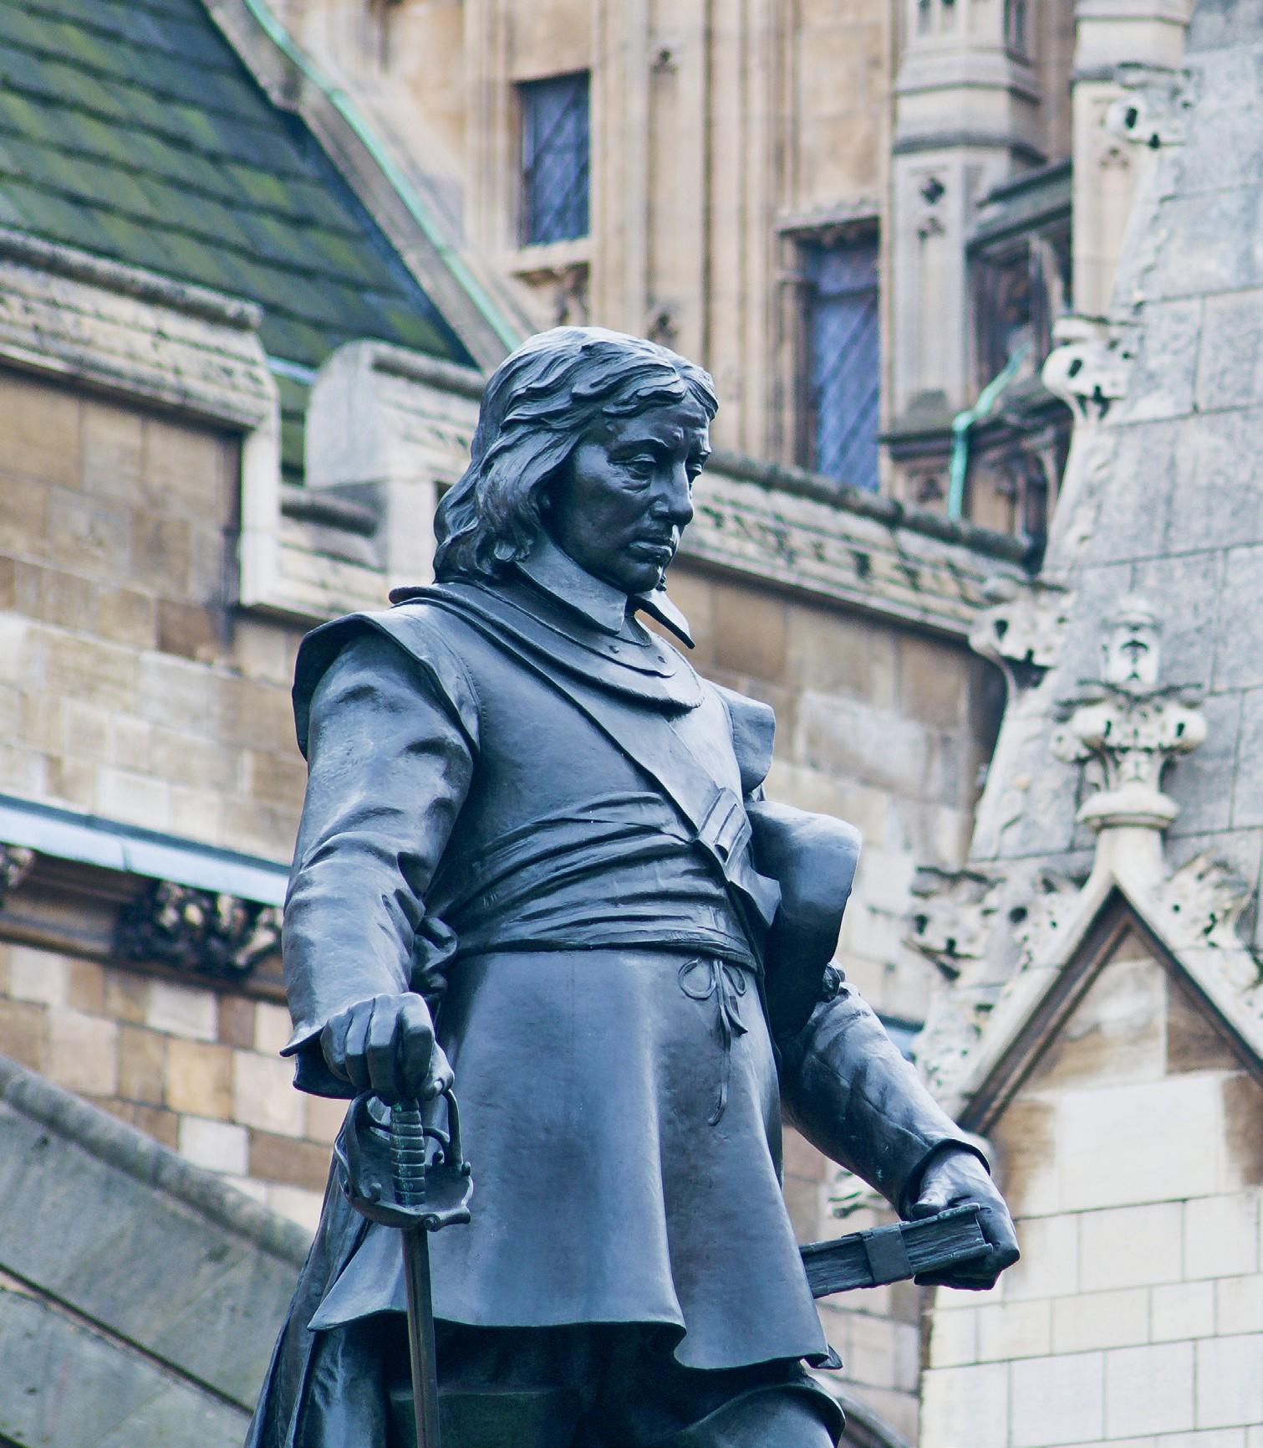

*By 1647, Cromwell was engaged in serious discussions with the Levellers*

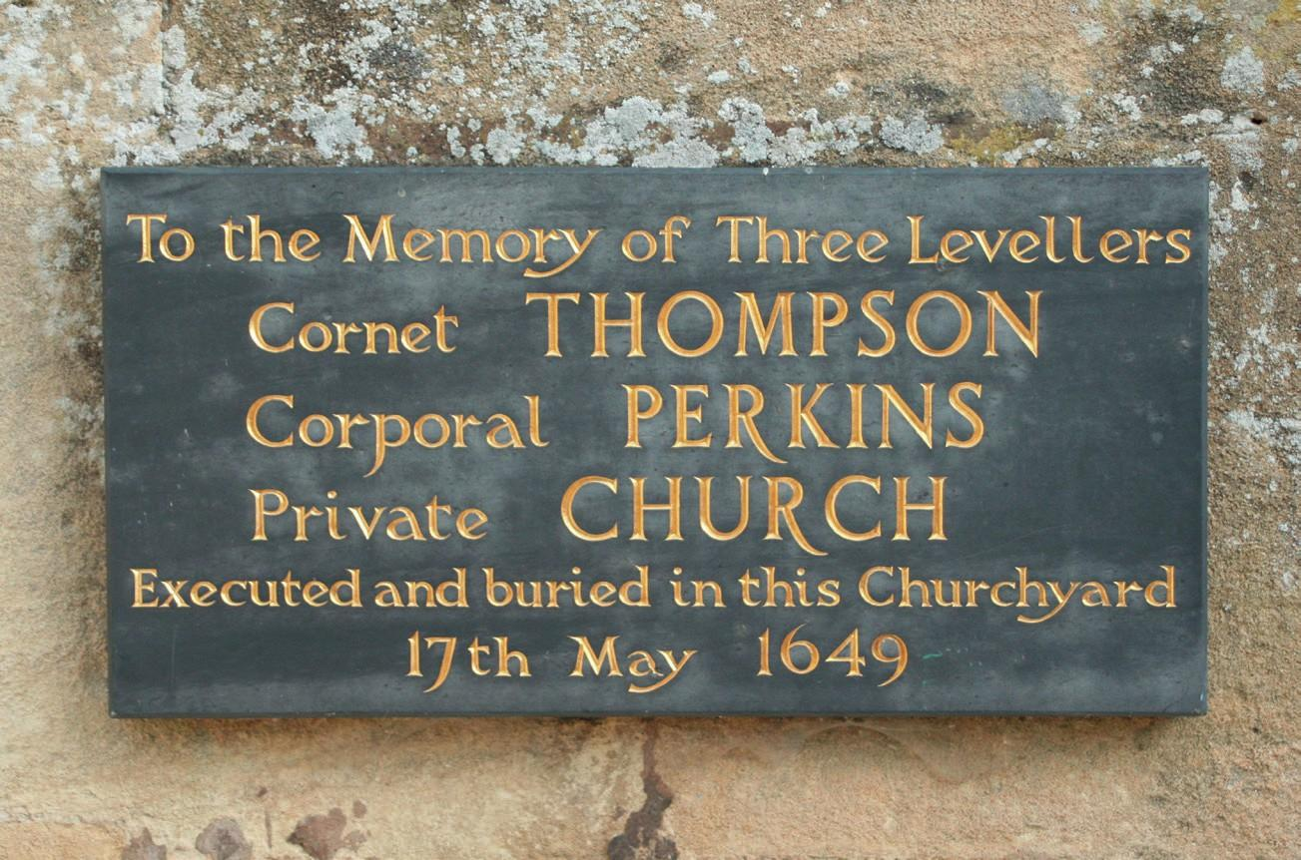

*Memorial to Levellers in Burford, Oxfordshire*

*The largest of these were the Clubmen movements, bands of armed neutrals whose main wish was for peace. Their sheer weight of numbers is impressive: close to 50,000 across the southwest of England. Compare that to the few thousand or so active Levellers (as opposed to those who merely signed their petitions but did not offer any other kind of support), or the even smaller number of Diggers, and a case can be made that the radicals were less important than Hill and Rees claim.*

***Anti-elite***

*Both movements had specific weaknesses, limiting their influence. Their radical programmes were never likely to win them support from the country’s wealthy elites who exercised considerable power at both a provincial and national level. The Diggers’ call for a radical redistribution of the country’s landed wealth alarmed landowners who moved quickly to shut down their colonies and ensure their prosecution for trespass.*

*While the Levellers claimed to respect the principle of private property, their call for more men to be given the right to vote still alarmed the wealthy, who saw it as a threat to their power. Cromwell, himself a wealthy landowner, described the Levellers as ‘despicable and contemptible … persons differing little from beasts.’ Grandees like Cromwell sought to crush the radicals rather than allow them political influence.*

***Army rejection***

*Furthermore, the Levellers’ main base of support, the rank and file of the New Model Army, proved unreliable. Most soldiers were more concerned with bread-and-butter issues than with theoretical debates about freedom and democracy. The period of peak army support for the Levellers, up to and including the summer of 1647, was also one in which soldiers’ pay was largely in arrears and their living conditions poor. Once the army’s leaders had moved to satisfy these material grievances in the autumn of 1647, the majority of soldiers abandoned the Levellers. When remaining Leveller supporters mutinied in October 1647, they were easily crushed by troops loyal to the generals.*

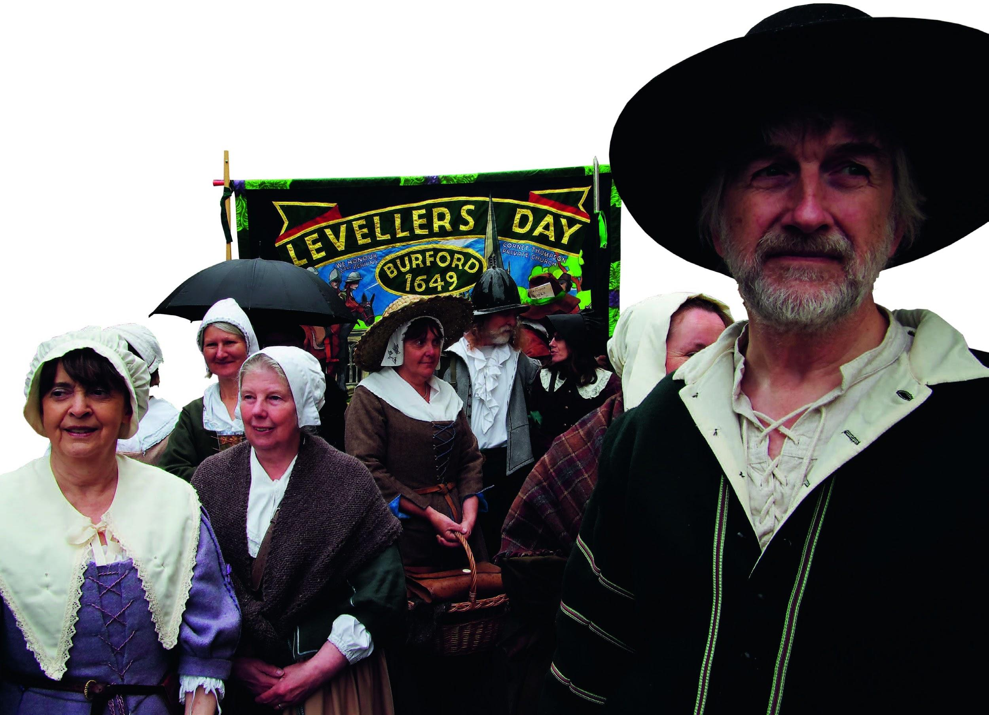

*Today, the Levellers and their radical contemporaries are remembered by some as left-wing heroes*

***Unworthy king***

*Finally, Charles I’s execution can be seen as caused more by his own actions than by radicals’ demands. By engaging in secret negotiations with the Scots and, in so doing, starting the Second Civil War in February 1648, Charles proved to Parliament that he could not be trusted and so effectively signed his own death warrant. It was Charles’s unfitness to govern, and not a Leveller-inspired desire to make England into a republic, that led to regicide in 1649.*

***Conclusions***

*The revisionist case is certainly convincing. It is uncontestable that left-wing historians, guided by admiration for radicals whose aspirations they share, exaggerate their significance. However, this does not mean that civil war radicals were completely unimportant. A middle ground can be mapped out.*

*In the first place, radical writers deserve to be credited for the originality of ideas which were far ahead of their time. The Levellers’ call for mass democracy would not be taken up again until the end of the eighteenth century and not realised in Britain before the 1860s. The Diggers’ arguments for a radical redistribution of property only began to be heard again with the emergence of socialist movements in the nineteenth and early twentieth centuries.*

*Furthermore, while the main parts of their programmes were not enacted, some of their suggestions were put into practice during the 1650s. These included the use of English, rather than Latin, in legal proceedings; reduced imprisonment of debtors; and the redistribution of parliamentary seats to take into account changes of wealth and population. These represented just a fraction of the full Leveller programme, and virtually none of the Diggers’, but does show that at least some of the radicals’ demands were acted upon even by Cromwell, their declared enemy.*

*It is possible, therefore, to see civil war radicals as original thinkers with some influence over events in the 1640s and 1650s without, however, assigning them a central role in the history of the English revolution.*

*Matthew Clark was a fellow and college lecturer in history at Pembroke College, Cambridge. He has since taught at Shrewsbury School and Our Lady’s Abingdon.*

### 

1. **How did the breakdown of censorship during the English Civil War period contribute to the rise of political radicalism?**
2. **In what ways did the aims and actions of the Diggers go beyond those of the Levellers, and how did this affect their reception by society?**
3. **How do revisionist historians such as John Morrill and Mark Kishlansky challenge the narrative presented by earlier left-wing historians like Christopher Hill?**
4. **Why did support for the Levellers among the New Model Army decline after 1647, and what does this suggest about the nature of their support base?**
5. **To what extent did the execution of Charles I result from Leveller influence, and what alternative explanation does the article offer?**
6. **Case study: 17th century Britain**

|  |  |
| --- | --- |
| As we have seen, Britain was subject to huge changes in many periods. Our course focuses on the seventeenth century, when it experienced several revolutions including the civil wars of the 1640s, the republic under Oliver Cromwell, & the Glorious Revolution of 1888. | (Pic: Clare Melinsky, Rampart Lions Press) |

**Must do:**

1. **Watch:** documentary [The English Civil War - A People Divided](https://www.youtube.com/watch?v=KDvQw9SzoV0) Note down dates of key events in seventeenth century Britain
2. **Read:** [**Smith's article on 17th century Parliaments**](https://drive.google.com/file/d/1bXUWCS6iRDFOw1a761e_nfc2jHQh_nRN/view?usp=sharing)
3. **Create:** a timeline showing 10 key events that you identify as being important to seventeenth century Britain. You must include at least one event from before 1630, and at least one from after 1660.

You **should**:

* Include a brief explanatory sentence about each event, and / or illustrate them with images or symbols
* Think carefully about Smith’s article and try to identify what arguments he puts forward

You **could:**

* Choose to present your work in a creative way - PowerPoint presentation, podcast, video or Ted talk.
* Watch [Michael Wood's Story of England](https://www.youtube.com/watch?v=fZZtgg6aCi8) – this episode looks at the history of one village & traces the links to the national picture from the Tudors through to the Industrial Revolution, including the period we cover in Paper 1.

****************************************************

**A Level Early Modern History: Course information & FAQs**

|  |  |  |
| --- | --- | --- |
| **Unit/Paper** | **% of 2 year course** | **Structure & assessment** |
| **Paper 1:** Britain 1625-1701: revolution, conflict & restoration | 30 | * Section A: essay (c.10 years) * Section B: essay (c.20 years, or 1625-88) * Section C: essay on interpretations of 1688-1701 |
| **Paper 2**: France in revolution 1774-99 | 20 | * Section A: contemporary source evaluation * Section B: essay |
| **Paper 3**: The witch craze in Britain, Europe & North America c.1580-c.1750 | 30 | * Section A: contemporary source evaluation (context = 1 of 5 depth studies) * Section B: essay on 1 of 5 depth studies * Section C: essay on change over 100 years |
| **Paper 4**: Historical Investigation | 20 | * 4000 word essay investigating & evaluating different historical interpretations |

|  |  |
| --- | --- |
| The main text we recommend is the official Pearson exam board one - [Edexcel AS/A Level History, Paper 1&2: Revolutions in Early Modern and Modern Europe Student Book](https://www.amazon.co.uk/Edexcel-Level-History-Paper-Revolutions/dp/144798532X/ref=sr_1_1?dchild=1&keywords=Revolutions+in+Modern+%26+Early+Modern+Europe&qid=1586765703&s=books&sr=1-1)  We suggest that students have their own copy to assist with homework & revision, but we don't normally require them to bring it to class as our teaching makes use of a whole range of other resources & strategies including non-public online archives that students access via the college library website. |  |

What else do I need?

You will need to bring a ring binder with dividers, some A4 lined paper, a pen, pencil and a highlighter. Coloured pens also come in handy!

How much homework/independent study will I get?

About 3 hours of ‘planned study’ each week.  This could be research, preparing for a group discussion or presentation, writing an essay, or revising for a timed essay or quiz.

What trips are planned?

This year we took part in the New York & Washington trip with the Politics Department, & we ran a research & using sources workshop using the Mass Observation Archive at Sussex University’s ‘The Keep’. In recent years we have also been to Edinburgh & the National Gallery in London. We hope to offer similar opportunities in the future.

**We’re really looking forward to meeting you - have a great summer and see you soon!**

**Any other questions? Drop us an email :)**

**Ruth Kelly (Programme Leader, History)** [rak@varndean.ac.uk](mailto:rak@varndean.ac.uk)

**A Level Early Modern History: course content in Y1**

**Paper 1 Britain 1625-1701**

* Quest for political stability inc. the Personal Rule, Civil Wars & Republic under Cromwell
* Religion, conflict & dissent inc. religious tensions during the reign of Charles 1st, the role of the Levellers
* Social & intellectual challenge e.g. political philosophy of Hobbes & Locke, new scientific ideas e.g. Newton & the Royal Society
* Economy, trade & empire e.g. agricultural developments, colonies in the Americas
* Analysing & evaluating interpretations on the debate on the Glorious Revolution 1688-1701
* The significance of revolutionary ideals in the establishment of a constitutional monarchy.
* The impact of the Toleration Act 1688 and the end of Anglican supremacy.
* The significance of the Triennial Act 1694 and the growth of parliamentary power.

**Paper 2 France in Revolution 1774-99**

* Origins & onset of revolution 1774-89 e.g. financial causes, the fall of the Bastille, Tennis Court Oath
* Revolution & the failure of constitutional monarchy 1789-93 inc Loui’s attempt to leave France in 1791, threats of counter-revolution
* National Convention, the Jacobins & the Terror 1793-94 inc. the assassination of Marat, the role of the Sans-Culottes
* From the Directory to Brumaire 1795-99 – the attempts to continue government via non-violent revolution before the emergence of Napoleon

**Reading List**

**Paper 1**

Hutton, R., *A Brief History of Britain 1485-1701*, Robinson, 2011 (a very readable expert overview of the period, issues & debates)

Mortimer, I., *The Time Traveller’s Guide to Elizabethan England*, Vintage, 2013 (focussed on the decades just before Paper 1 starts, but a very scholarly & fascinating sense of the whole period, based on the premise of what you would need to know if you suddenly found yourself in early modern England)

Anderson, A., *An Introduction to Stuart Britain 1603-1714: Access to History in Context*, Hodder, 1999 (a great A Level textbook covering the whole period)

**Paper 2**

Rees, D., *France in Revolution 1774-1815: Access to History*, Hodder, 2019 (a very accessible A Level textbook)

David Andress [on the ideology of 1789 (HistoryExtra.com)](https://www.historyextra.com/period/georgian/fighting-for-freedom-the-storming-of-the-bastille-and-the-french-revolution/)