

**Course Start**

Course Start is independent learning you need to complete as a fundamental part of your introduction to the course. It should take you approximately 5 hours to complete.

|  |  |
| --- | --- |
| Course Name | **Geography** |
| How this **Course Start** fits into the first term of the course | There are three aspects to our Course Start:   1. Think about why you want to study Geography and what you see as the most important global issues for geographers in the 21st century 2. Develop some background knowledge of current issues that link to the Geography Specification and help develop your independent study skills 3. Use data analysis skills to help you consider some of the key ideas in the topic of the Water Cycle and Water Insecurity |
| How will my **Course Start** learning be used in lessons? | In the first half term, we shall be studying the Water Cycle topic, where you will apply the learning from the tasks you have studied.  Our first lesson will be based on discussing your ideas and research with other students. |
| **Course Start** learning objectives | * To understand the importance of Geography in understanding a wide range of contemporary issues * To practise research into key geographical topics. * To develop and expand your geographical analysis linked to the Water Cycle and Water Insecurity |
| What **Study Skills** am I developing in this? | * **Research skills** - using suggested sources and identifying key information * **Communication skills** - putting your ideas and findings into effective writing * **Data analysis -** describing and explaining the trends in numerical data * **Application of Geographical concepts**  - applying your knowledge and understanding of key geographical ideas to current contexts |

**Expectations for: Geography**

Our specification is: [Edexcel Geography A Level (2016)](https://qualifications.pearson.com/en/qualifications/edexcel-a-levels/geography-2016.html)

|  |
| --- |
| **What this course involves** |
| Completing Planned Study (independent learning) of 5 hours per week. This will include weekly ‘retrieval tasks’ as ongoing revision. |
| Writing tasks involving a range of practice exam questions (e.g. from 3 mark short answers to 24 mark essays) |
| Application of numerical skills including analysing graphs and data, plus using statistical analysis (e.g. standard deviation and Spearman Rank) |
| Completing the coursework unit (20% of the A Level grade) which will entail forming a hypothesis, collecting and analysing data and writing conclusions. |
| Engaging in discussions and presentations based on the themes studied. |
| Studying a diverse range of themes: water cycle and water insecurity, globalisation, regenerating places, coastal landscapes and change, tectonic processes and hazards; carbon cycle and energy security; superpowers; migration, identity and sovereignty. |
| Developing independent learning skills (e.g. time management, preparing for each week’s lessons, identifying gaps in your knowledge, completing independent revision) |
| Participating in field trips across the two-year course (there will be some changes for these trips). |
| Taking part in enrichment activities such as local lectures, visiting speakers at lunchtimes and college environmental projects. |
| Reading and researching around the course, completing extension work and staying up to date with relevant current affairs |
| Preparing for the synoptic paper (Paper 3) by applying a wide range of geographical concepts to unfamiliar contexts |
| Revising two year’s worth of content in preparation for the final A Level exams |

**Geography at Varndean: Course Start Booklet**

Congratulations on an excellent choice of A Level!

You are about to begin a fantastic A-level course where you will have the chance to really enhance your understanding of the world around you. The learning in this booklet is designed to help you make the best possible start to the course. Some of it is thinking about some important basics, some of it is about extending and exploring what is happening in our world, and finally some is an introduction to our first topic in September.

***Guidance:***

***➢ Please complete all activities listed below.***

***➢ You may complete the work by hand or electronically.***

***➢ Please ensure work is presented clearly with different tasks labelled***

***➢ If you complete the work electronically, it must be printed out.***

***➢ Work (clearly named) should be brought in on your first day of lessons.***

**TASK 1 - 1 hour**

Write one paragraph for each of the following prompts. You may want to carry out research to support your writing.

1. Why is Geography A Level an important subject to study?
2. What are the most important ways in which humans have altered and continue to alter our environment?
3. In your opinion, which global issue is the most crucial for humans to address in the 21st century?
4. Identify one news article from 2025 so far that is related to the study of Geography. Briefly summarise the article and how you think it links to Geography.

**TASK 2 - 2 hours**

To be a great geographer, you will need to be curious about the world around you and seek ways to broaden your knowledge and understanding. Below are some links to podcasts, books and documentaries which provide a great way of staying inspired and engaging with Geography.

You need to choose at least one of the following resources to read/ watch/ listen to. All of them link to a topic you will study in the next 2 years! You then need to write a report about what you’ve learned using the template below.

**Podcasts:**

* **Why is China building the world’s biggest dam?** China has already built the world’s biggest hydropower dam, but it has announced plans to build another one, three times larger, in Tibet. <https://www.bbc.co.uk/programmes/w3ct5xjk>
* **Do we need a new NATO?** Europe’s leaders are having to consider whether they could potentially go it alone without American military aid and increase spending on defence. <https://www.bbc.co.uk/programmes/w3ct5xjs>
* **Will beaches survive climate change?** In this episode, Ninja investigates the threat that rising sea levels pose for the world’s beaches. Can they survive the 21st century? <https://open.spotify.com/episode/4DWPe2VcVmHbgAKC84mk3H>
* **Natural hazards and disaster risk** In conversation with Dr Martin Parham, lecturer in disaster management in the HCRI at the University of Manchester, talking all things disaster risk with a specific focus on Small Island Nations. <https://www.rgs.org/schools/resources-for-schools/natural-hazards-disaster-risk-with-dr-martin-parham>
* **A conversation with Tim Marshall** Author of the seminal book Prisoners of Geography <https://www.rgs.org/schools/resources-for-schools/a-conversation-with-tim-marshall>
* **Trump doubles tariffs on steel imports to 50%** At a rally in Pittsburgh, Pennsylvania, President Donald Trump announced that the US will double tariffs on steel imports from 25% to 50% to boost the local steel industry. <https://www.bbc.co.uk/programmes/w172zrs2q4ry0mg>
* **Surrendering to the waves?** Qasa Alom reports on the tough decisions which may have to be taken about flood defences along the UK's coastline, as sea levels inexorably rise. <https://www.bbc.co.uk/programmes/m001jktn>

**Documentaries (all on BBC iPlayer):**

* **The Americas with Simon Reeve.** In this first leg of his epic journey, Simon travels from the frozen beauty of Alaska down through Canada to Vancouver and the border with the United States. <https://www.bbc.co.uk/iplayer/episode/m00095nt/the-americas-with-simon-reeve-series-1-episode-1>
* **Expedition volcano** Chris Jackson, Xand van Tulleken and Aldo Kane take part in an expedition to Nyiragongo - one of the world's most dangerous and spectacular volcanoes. <https://www.bbc.co.uk/iplayer/episode/b09hlzbb/expedition-volcano-series-1-episode-1>
* **Earth from space: changing planet** <https://www.bbc.co.uk/iplayer/episode/p072n8m0/earth-from-space-series-1-4-changing-planet>
* **Earth: Human** Today, Earth is a human world, home to eight billion people and counting. Humans now have a greater effect in shaping Earth’s surface than many natural processes. <https://www.bbc.co.uk/iplayer/episode/p0fpwmkm/earth-series-1-5-human>
* **Climate change - the facts** After one of the hottest years on record, Sir David Attenborough looks at the science of climate change and potential solutions to this global threat. <https://www.bbc.co.uk/iplayer/episode/m00049b1/climate-change-the-facts>

**Books**

You can pick one chapter! (Check to see if these are available in your local library):

* **Mountains of Fire: The Secret Lives of Volcanoes** (Clive Oppenheimer, 2023)
* **Prisoners of Geography** (Tim Marshall, 2016)
* **The Power of Geography: Ten Maps that Reveal the Future of Our World** (Tim Marshall, 2021)
* **Factfulness: Ten Reasons We’re Wrong About the World and Why Things are Better Than You Think** (Hans Rosling, 2018)
* **Outside the Box: How Globalisation Changed from Moving Stuff to Spreading Ideas** (Marc Levinson, 2020)
* **Africa Is Not a Country** (Dipo Faloyin, 2022)
* **Another England: How to Reclaim Our National Story** (Caroline Lucas, 2024)

**Task 2 Report:**

Now you’ve read or watched or listened to some great Geography information, tell us what you learnt below

|  |
| --- |
| Media I used: |
| What are the main things you learnt from the resource? |
| What did you find most interesting/ enjoyable about it? |
| How do you think this will link to what we study in A Level Geography? |
| What questions did it leave you with that you would like to research further? |

**TASK 3 - 2 hours**

Use the data to answer the following questions. Each resource has 2 questions with it, and you should aim to write a paragraph for each one. You may need to research the definitions of some words to help you!

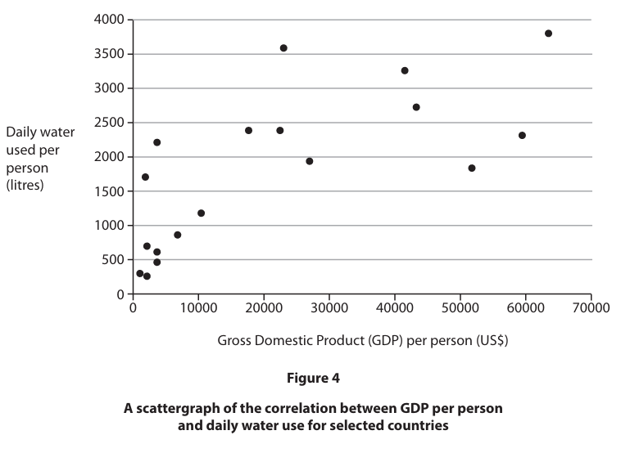

1. Study Figure 4 above.
   1. Describe the pattern shown in the graph
   2. Explain what you think the possible causes of this pattern might be

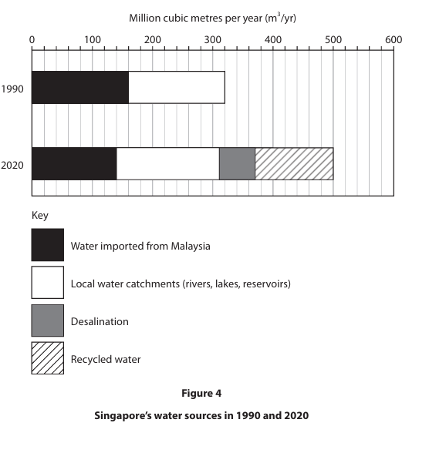

1. Study Figure 4 above.
   1. Describe the changes in Singapore’s water sources from 1990-2020 (you might have to research what some of the words mean!)
   2. Decide which year Singapore had a more sustainable water supply and justify why using the data from the graph.

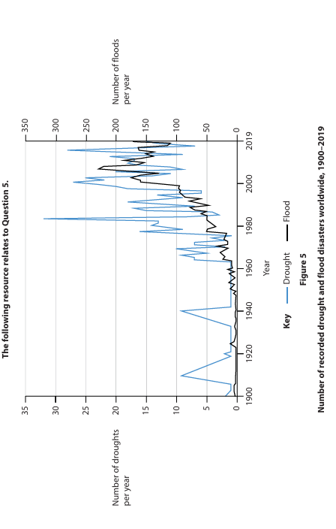

1. Study Figure 4 above.
   1. Describe the trends in drought and flood disasters since 1900.
   2. Explain what you think the possible causes of these trends might be

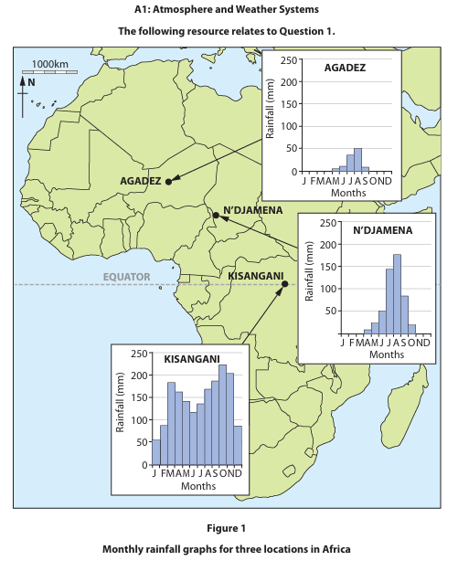

1. Study Figure 1 above.
   1. Describe the variations in rainfall across the 3 locations in Africa
   2. Explain why the amount of rainfall might cause different hazards in the three locations

**Enjoy your summer break and we’ll see you soon!**