**Course Start**

Course Start is independent learning you need to complete as a fundamental part of your introduction to the course. It should take you approximately 5 hours to complete.

|  |  |
| --- | --- |
| **Course Name** | **ENVIRONMENTAL SCIENCE** |
| How this **Course Start** fits into the first term of the course  Details of the tasks are shown at the end of this document. | There are four aspects to our Course Start:   1. Think about why you want to study Environmental Science and what the most important issues are for Environmental Scientists to help solve 2. Increase your background knowledge of climate change, develop your independent study skills and prepare for one the of the first topics you will study (The Atmosphere) 3. Start preparing for one of the first topics you will study (The Living Environment) by considering some of the key features that allow life to thrive on planet Earth 4. Keep up your Maths skills that you needed for your GCSEs by attempting some maths questions |
| How will my **Course Start** learning be used in lessons? | In the first year, we shall be studying The Living Environment and The Physical Environment, where you will apply the learning from the tasks you have studied.  Our first lesson will be based on discussing your ideas and research with other students.    We will build on the Maths task with the skills we practice in the first year.  All four activities will feed into your study over the whole course because they help you to begin to develop research skills and understanding of the course content. |
| **Course Start** learning objectives | * To consider the importance of Environmental Science as a subject and your motivations for studying it * To research using suggested sources to identify key information and increase your understanding of environmental issues * To understand the foundations of sustainability which lie in the relationship between life and the non-living environment such as gases and water. * To practice some of the mathematical skills that are needed on the course. |
| Study Skills | * **Research skills** - Searching and selecting appropriate material from different types of media such as TV news, newspapers and web- based sources. * **Making connections**  - Using your existing knowledge and the new information you research to deepen your understanding of key topics for the Environmental Science A Level * **Communication skills** - Practising and developing your ability to present ideas and information in written form and then to be able to discuss and explain this in group situations * **Data skills** - Solving mathematical problems building on the range of mathematical skills required at GCSE |

**Expectations for: Environmental Science**

Our specification is: [AQA Environmental Science](https://www.aqa.org.uk/subjects/environmental-science/a-level/environmental-science-7447/specification)

|  |
| --- |
| **What this course will require** |
| Completing Planned Study (independent learning) of 5 hours per week. This will include weekly ‘retrieval tasks’ as ongoing revision. |
| Writing tasks involving a range of practice exam questions (from 1-25 mark written responses) |
| Application of numerical skills including analysing graphs and data, producing graphs, statistical analysis, equations and calculations. |
| Engaging in discussions and presentations based on the themes studied. |
| Reading and researching around the course, completing extension work and staying up to date with relevant current affairs |
| Studying a diverse range of topics: including life processes; conservation; biogeochemical cycles; natural resources and energy; water cycle; sustainability. |
| Developing independent learning skills (e.g. time management, preparing for each week’s lessons, completing learning tasks outside lessons) |
| Participating in field trips across the two-year course (there will be some changes for these trips). |
| Working scientifically to: develop a range of practical laboratory skills and fieldwork studies to embed scientific principles and scientific skills. |
| Building on scientific skills to enable working safely and competently in a laboratory' |
| Taking part in enrichment activities such as local lectures, visiting speakers at lunchtimes, joining in with campus biodiversity activities and college environmental projects. |
| Thinking synoptically and making links between different areas of study |

**Welcome to Environmental Science at Varndean**

Congratulations on an excellent choice of A Level!

You are about to begin a fantastic A-level course where you will have the chance to really enhance your understanding of the planet you live on. The learning in this booklet is designed to help you make the best possible start to the course.

***Guidance:***

***➢ Please complete all activities listed below.***

***➢ You may complete the work by hand or electronically.***

***➢ Please ensure work is presented clearly with different tasks labelled***

***➢ If you complete the work electronically, it must be printed out.***

***➢ Work (clearly named) should be brought in on your first day of lessons.***

|  |  |
| --- | --- |
| **TASK 1**  **45 minutes** | Write one paragraph for each of the following prompts. You may want to carry out research to support your writing.  a) Why is Environmental Science A Level an important subject to study?  b) What are the biggest problems in the world that Environmental Scientists can help solve both now and in the future?  c) What are some solutions to these global problems that Environmental Scientists can help to develop? |
| **TASK 2**  **1 hour and 30 minutes** | A key theme that runs throughout the course is climate change, which is very topical!  You are going to carry out some wider research on the theme of climate change, either in terms of its causes, impacts or solutions. You need to choose at least one of the following resources to read/ watch/ listen to. You then need to write a summary of the key information that you have learnt about either the causes, impacts or solutions of climate change (or maybe all three!)  **News sources:**   * Inside Climate News <https://insideclimatenews.org/> * Carbon Brief <https://www.carbonbrief.org/> * BBC News (Climate page) <https://www.bbc.co.uk/news/topics/cmj34zmwm1zt>   **Podcasts:**   * BBC World Service - The Climate Question <https://www.youtube.com/playlist?list=PLz_B0PFGIn4dlFahw2svjb6-aW_BVOn4x> * Outrage and Optimism <https://www.outrageandoptimism.org/> * Mongabay - Climate news podcasts <https://news.mongabay.com/?s=&topics=climate&formats=podcasts>   **Documentaries:**   * Climate Change: The Facts <https://www.bbc.co.uk/programmes/m00049b1> * Before the Flood <https://www.youtube.com/watch?v=zbEnOYtsXHA> * 1.5 Stay Alive: Science Meets Music in the Caribbean <https://www.youtube.com/watch?v=vH1SwOLFH_w>   **Books:** *(If you choose to read a book then you might just want to summarise 1 chapter. Most of these will be available to borrow from your local library)*   * The Climate Book (Greta Thunberg, 2022) * There is No Planet B: A Handbook for the Make or Break Years (Mike Berners-Lee, 2019) * The Future We Choose: Surviving the Climate Crisis(Christiana Figueres and Tom Rivett-Carnac, 2020) * How to Avoid a Climate Disaster: The Solutions We Have and the Breakthroughs We Need (Bill Gates, 2021) |
| **TASK 3**  **1 hour and 30 minutes** | One of the first topics you will study in A Level Environmental Science is ‘The Conditions for Life on Earth’. Earth has a wide range of physical features that have allowed both plant and animal life to develop.  You are going to write a report to explain the five most important physical features of earth. For each one you need to identify what the feature is and then explain why it is important for life to thrive. Write this up as a short report.  The report should be 1-2 sides of A4 and should be laid out with a main title of ‘The Conditions for Life on Earth’ and subheadings for each of the 5 features. It should include pictures or diagrams for each feature and you should include the sources of the information you have researched. |
| **TASK 4**  **1 hour** | Please complete the maths skills questions on the attached worksheet. You will need to show your workings for all questions. Some of them are more straightforward and some of them are quite tricky - just do your best!  You may find it helpful to use your GCSE Maths notes and revision materials to help with the questions. |

**Task 4 - Maths skills questions**

**1.**

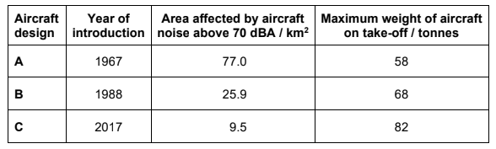

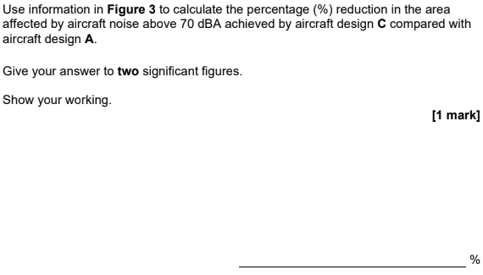

**2.**

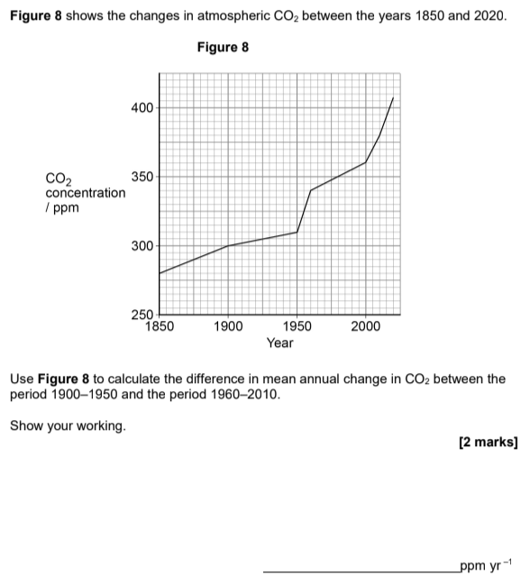

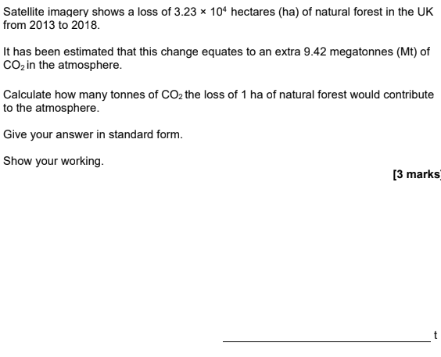**3,**

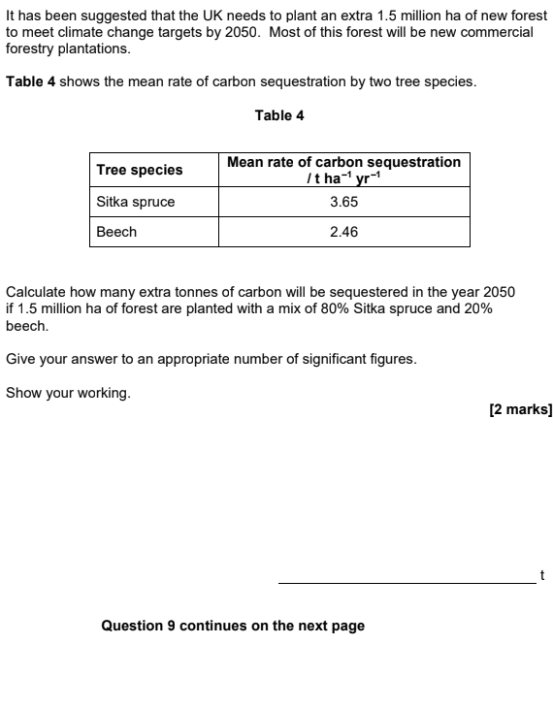

**4.** 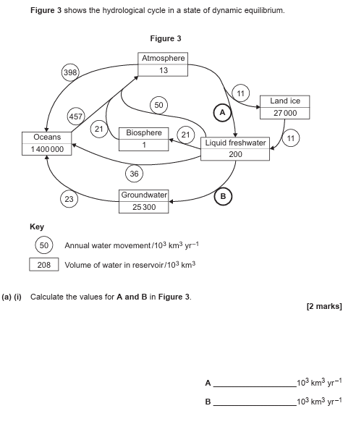

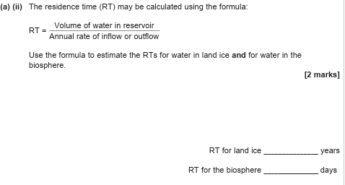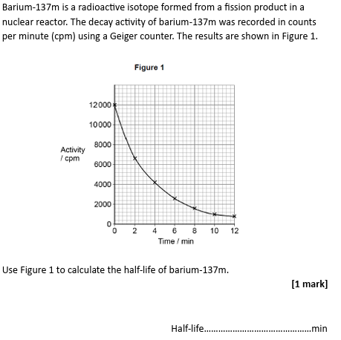

**5.**

**6.** 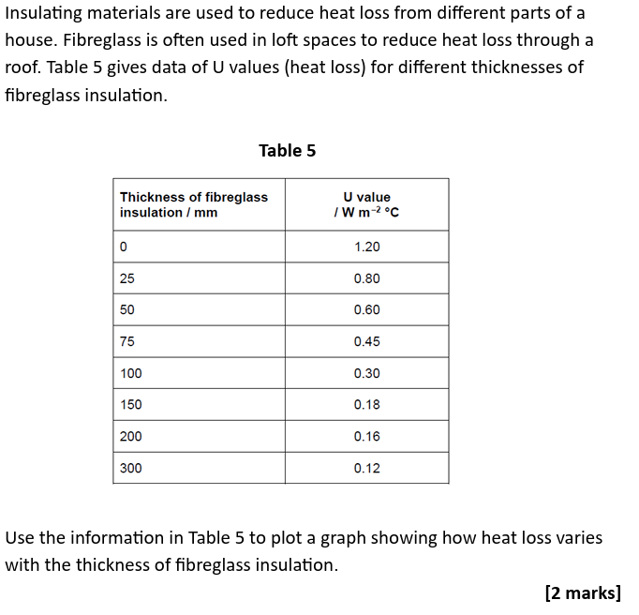

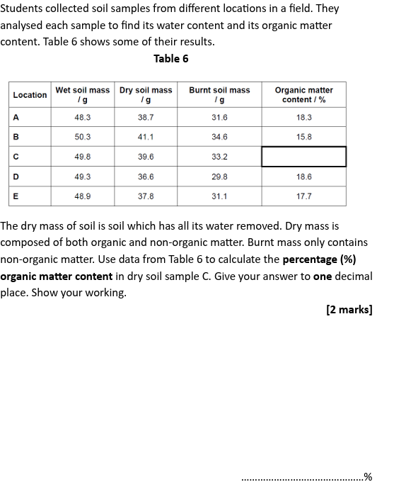**7.**

**8.** 