

**Course Start**

Course Start is independent learning you need to complete as a fundamental part of your introduction to the course. It should take you approximately 5 hours to complete.

| **Course Name** | **AAQ Engineering (Extended Certificate)** |
| --- | --- |
| How this **Course Start** fits into the first term of the course | The first topics you will study in September are Mathematics and Science for Engineering. These concepts are essential for an understanding of Engineering. |
| How will my **Course Start** learning be used in lessons? | The first few weeks of the course will involve a brief recap of GCSE ideas of Maths and Physics then these concepts will be developed to the level needed for this course. The Course Start will give you a good preparation for these topics. |
| **Course Start** learning objectives | Be confident with the following concepts:   * Significant figures, standard form, prefixes and algebra * Velocity-time graphs, equations of motion, resultant forces and energy * Charge, voltage, electrical power, series and parallel circuits |
| Study Skills | * Organisation and time-management * Mathematics skills * Self-study and research skills |

**Expectations for: AAQ Engineering (Extended Certificate)**

Our specification is: [AAQ Engineering Extended Certificate](https://www.ocr.org.uk/qualifications/cambridge-advanced-nationals/engineering-level-3-h027-h127/#extended-certificate)

| **What this course involves** |
| --- |
| Completing Planned Study (independent learning) of 5 hours per week. |
| Studying a range of topics related to Engineering (Mathematics, Science, Mechanical and Electrical Engineering) and applying this knowledge to solve Engineering problems. |
| Application of mathematical skills and understanding to range of Engineering situations. |
| Developing skills to carry out practical investigations and using tools in a safe and methodical manner. |
| Completing three internally assessed units (approx. 60% of the final grade) which will entail completing numerous tasks and submitting these in the form of a report.  e.g. Computer Aided Design project. |
| Developing independent learning skills (e.g. time management, preparing for each week’s lessons, completing learning tasks outside lessons). |

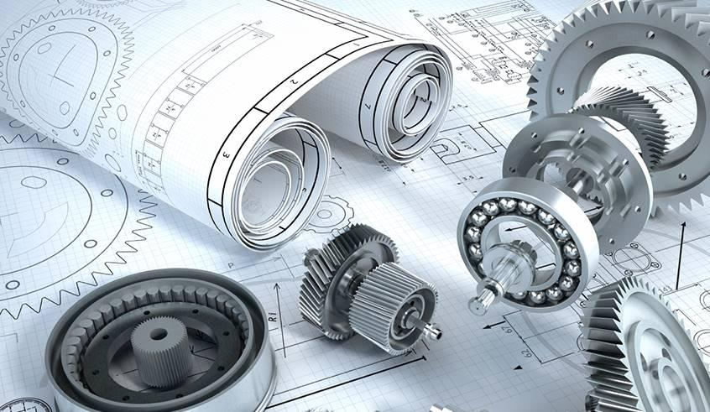

**AAQ Engineering**

**Extended Certificate Level 3**

**Course Start**

**Course Overview**

The two-year course is comprised of 5 units, some of which are examined and some are assessed internally (see below).

Examined Units:

F130 Principles of Engineering 25%

F131 Materials Science and Technology 17%

Internally assessed units:

F132 Engineering in practice 25%

F133 Computer Aided Design 17%

F137 Electrical devices and circuits 17%

**Resources & materials**

You will need the following materials for this course

* Scientific Calculator
* Stationary (A4 lined paper, pens, lever arch files, folders)
* Textbook – details to be confirmed

**Recommended reading**

To get a broader understanding of the course, it is recommended that you read some books on the subject of Engineering as well as regularly looking at Engineering websites – see examples below.

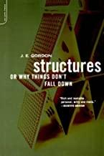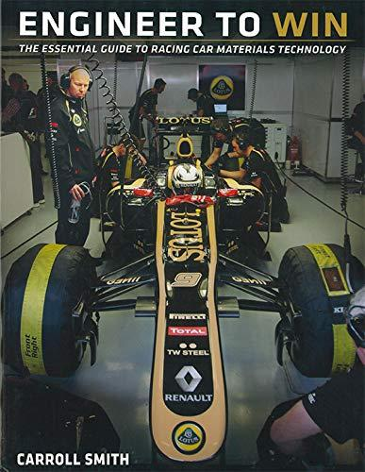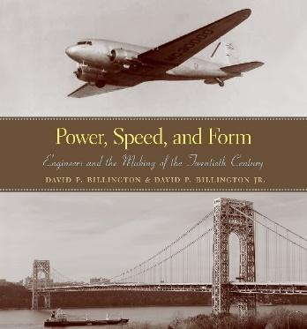

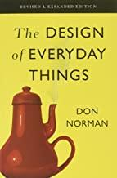

* *Structure (or Why Things don’t Fall Down)*, J.E. Gordon, Da Capo Press

# *The Design Of Everyday Things*, Don Norman, Basic Books

# *Engineer to Win* by Carroll Smith, Carroll Smith, Consulting Incorporated

## *Success Through Failure: The Paradox of Design*, Henry Petroski, Princeton Uni Press

# *Power, Speed and Form*, David P Billington, Princeton University Press

# *Simple Science of Flight: From Insects to Jumbo Jets*, [Henk Tennekes](https://www.amazon.co.uk/s/ref=dp_byline_sr_book_1?ie=UTF8&field-author=Henk+Tennekes&text=Henk+Tennekes&sort=relevancerank&search-alias=books-uk), MIT Press

[www.engadget.com](https://www.engadget.com/)

[www.theengineer.co.uk](http://www.theengineer.co.uk)

[www.eurekamagazine.co.uk](http://www.eurekamagazine.co.uk)

[interestingengineering.com](https://interestingengineering.com/)

[www.gadgette.com](http://www.gadgette.com/)

**Pre-course content**

The following pages contain some of the basic Maths and Physics concepts that you will need to understand in the first few weeks of the Engineering course in September. Most of these ideas and skills are GCSE level but some ideas are more advance i.e. what you will be doing in the first few weeks of the course in September.

Read the pages below then answer all the questions on page 6 (solutions provided on page 7).

**Significant figures**

Dividing 24 by 4.6, gives the answer 5.21739130434… It is very inconvenient to give the answer with so many figures so for **convenience** we express it to a certain number of **significant figures.**

* The first significant figure of any number is **the first digit which isn’t a zero**
* The 2nd, 3rd, 4th, etc. significant figures follow on immediately, **regardless of being zeros or not zeros** e.g. 0.002309

sig figs 1st 2nd 3rd 4th

* After rounding off the last digit, **end zeros** must be filled in up to, but not beyond, the decimal point

e.g. to 3s.f. to 2s.f. to 1s.f.

54.75 54.8 55 50

0.04592 0.0459 0.046 0.05

**Significant Figures in Physics**

In Physics the number of significant figures you give, tells us something about the **accuracy** of the measurement or answer. For example to write the above answer as 5.2 cm means we know that the 5 is definite but the “2” is a bit uncertain and the answer could be 5.1 or 5.3 cm. ( in other words, the answer is only known to ±0.1cm . If the answer is given as 5.22 cm then this tells us that the 5 and the first 2 are certain but that the second 2 is uncertain e.g. the length could be 5.21 or 5.23 cm. In other words the length is known to ± .01 cm. If the answer for the length is given as 5.217 cm this implies a very accurate answer – correct to ±0.001 cm.

Therefore, the number of significant figures you use in Physics practical activities and problem solving is very important in giving us an indication of the accuracy of the measurement or the final answer. There is a specific rule for practical data (which we will learn later) but, **in general, you should write your answer to 2 or 3 significant figures.**

**Standard form**

To convert a number such as 46 700 to standard form, the number between 1 and 10 is 4.67. The power of ten is equal to the number of places that you must move the decimal point to get 46 700. In this case it is 4 places. Therefore 46 700 in standard form is 4.67 x 104

To convert a number such as 0.000 067 to standard form, the number between 1 and 10 is 6.7. The power of ten is the number of places you must move the decimal point to get to 0.000 067, expressing it as a negative power. In this case -5, so 0.000 067 in standard form is 6.7 x 10-5

You will need to learn how to use our calculator to input numbers in standard form. This is usually

done using the “EXP” button or the “x10x” button. You will also need to use the “x/-“ button.

**Prefixes**

You will be familiar with some of these pre-fixes from GCSE. You will need to know most of these pre-fixes for the first year of Engineering and all of them for year 2:

femto (f) 10-15 micro (μ) 10-6 mega (M) 106

pico (p) 10-12 milli (m) 10-3 giga (G) 109

nano (n) 10-9 kilo (km) 103 tera (T) 1012

**Describing motion**

The speed of a moving object can be calculated if the distance travelled and the time taken are known. The faster an object moves, the steeper is the line representing it on a distance-time graph.

The velocity of an object is its speed in a particular direction. In velocity-time graphs sloping lines represent steadily increasing or decreasing velocities. Horizontal lines represent movement at constant velocities.

When an object moves in a straight line at a steady speed, you can calculate its speed if you know how far it travels and how long it takes. This equation shows the relationship between speed, distance travelled and time taken:

Speed is distance divided by time taken.

For example, a car travels 300m in 20s. Its speed is 300 ÷ 20 = 15m/s.

**Distance-time graphs**

When an object is stationary, the line on the graph is horizontal. When an object is moving at a steady speed, the line on the graph is straight, but sloped. The diagram below shows some typical lines on a distance-time graph.

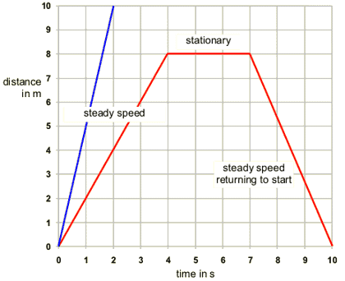

Note that the **steeper** the line, the greater the **speed** of the object. The blue line is steeper than the red line because it represents an object moving faster than the object represented by the red line.

The red lines on the graph represent a typical journey where an object returns to the start again. Notice that the line representing the return journey slopes downwards.

Changes in distances in one direction are positive, and negative in the other direction. If you walk 10m away from me, that can be written as +10m; if you walk 3m towards me, that can be written as –3 m.

**Velocity-time graphs**

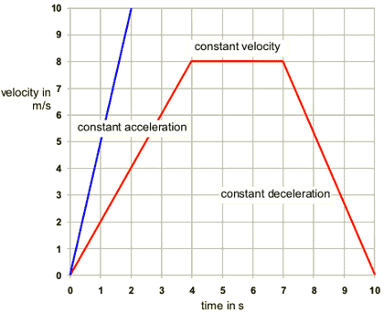

The **velocity** of an object is its **speed** in a particular **direction**. This means that two cars travelling at the same speed, but in opposite directions, have different velocities. One velocity will be **positive**, and the velocity in the other direction will be **negative**.

The vertical axis of a velocity-time graph is the velocity of the object and the horizontal axis is the time taken from the start.

When an object is moving with a constant velocity, the line on the graph is horizontal. When an object is moving with a steadily increasing velocity, or a steadily decreasing velocity, the line on the graph is straight, but sloped. The diagram shows some typical lines on a velocity-time graph.

The steeper the line, the more rapidly the velocity of the object is changing. The blue line is steeper than the red line because it represents an object that is increasing in velocity much more quickly than the one represented by the red line. Notice that the part of the red line between 7 and 10 seconds is a line sloping downwards (with a negative gradient). This represents an object that is steadily slowing down.

**Describing motion**

* The gradient of a distance-time graph represents the speed of an object.
* The gradient of a velocity-time graph represents the acceleration of an object.
* The distance travelled is equal to the area under a velocity-time graph.

*speed (m/s) = distance (m) / time (s)*  *acceleration (m/s2) = change in velocity (m/s)*

*time (s)*

**Algebra – solving simple equations**

The best way to solve an equation is by using 'inverses', or undoing what the equation is doing. To use this method to solve equations remember that:

* Adding and subtracting are the inverse (or opposite) of each other.
* Multiplying and dividing are the inverse of each other.

First write down the expression, e.g. 2a + 3 = 7

Then undo the + 3 by subtracting 3 (Remember, to do it to BOTH sides) 2a + 3 - 3 = 7 - 3

so 2a = 4

Undo the multiply by 2 by dividing by 2 - again on both sides: 2a ÷ 2 = 4 ÷ 2

The answer is: **a = 2**

**Dynamics (forces and motion)** 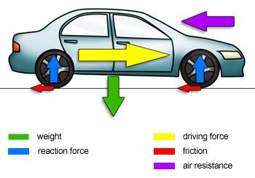

Sometimes several forces act on the same object. Look at the diagram of a moving car on the right. There are several forces acting on the car, shown by the arrows.

* Gravity pulls down on the car.
* The reaction force from the road pushes up on the wheels.
* The driving force from the engine pushes the car along.
* There is friction between the road and the tyres.
* Air resistance acts on the front of the car.

The **resultant force** is the sum of all the different forces acting on the car.

You have to take account of the directions – the reaction forces on the wheels (blue arrows) add up to the same as the weight (green arrow), so these cancel out. The driving force from the engine (yellow arrow) is in the opposite direction to the counter forces of friction (red arrows) and air resistance (purple arrow).

When the car is increasing its speed then all these forces add to give a single resultant force **forwards**.

**Movement with balanced and unbalanced forces**

A car or bicycle has a **driving force** pushing it forwards. There are always **counter forces** of air resistance and friction pushing backwards. You need to know how these forces compare if you are to predict what will happen to the speed of a moving object.

* If the driving force is **greater than** the counter forces, there is a resultant force forwards. This will make the car **speed up**.
* If the driving force is **less than** the counter forces, there is a resultant force backwards. This will make the car **slow down**.
* If the driving force is the same as the counter forces, there is no resultant force, and so no change in velocity.
* If the car is already moving, it will carry on at a steady speed in a straight line.
* If the car is not moving, it will stay still.

**Energy**

Work done and energy transferred are measured in joules (J). The work done on an object can be calculated if the force and distance moved are known.

* Objects raised against the force of gravity contain gravitational potential energy.
* The more mass an object has and the faster it moves, the more kinetic energy it has.

This equation shows the relationship between work done, force applied and distance moved:

**work done (joules, J) = force (newtons, N) x distance (metres, m)**

The distance involved is the distance moved in the direction of the applied force.

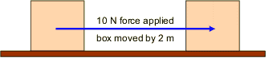

**Weight**

You should know and be able to use the relationship between weight, mass and gravitational field strength. Gravitational field strength is measured in **newtons per kilogram, (N/kg)**, and it is often simply referred to by its symbol: **g**.

**weight (newton, N) = mass (kilogram, kg) x gravitational field strength (N/kg)**

The gravitational field strength on the Earth’s surface is about **9.81 N/kg.**

**Gravitational potential energy (GPE)**

If you lift a book up onto a shelf you have to do work **against** the force of gravity. The book has gained **gravitational potential energy**. Any object that is raised against the force of gravity has an **increase** in its gravitational potential energy.

**change in GPE = weight x change in height**

For example, if a 1N weight is raised by 5m it gains 1 × 5 = 5J of gravitational potential energy.

**Kinetic energy (KE)**

Every moving object has kinetic energy (**KE**). The more mass an object has and the faster it is moving, the more kinetic energy it has. So the bigger the object, the faster it will move.

**kinetic energy = 1/2 × mass × speed2**

**Conservation of energy**

Energy is always **conserved** – the total amount of energy present stays the same before and after any changes.

**Electricity**

# Electrical charge and current

There are two types of current: direct and alternating. In a direct current, the flow of electrons is consistently in one direction around the circuit. In an alternating current, the direction of electron flow continually reverses.

## Charge

Electrons are negatively charged particles and they transfer energy through wires as electricity.

Charge is a property of a body which experiences a force in an electric field. Charge is measured in coulombs (C).

Since electrons are so small and one electron will not have much of an effect anywhere, it is more useful to refer to packages of electrons. One coulomb of charge is a package equivalent to 6,250,000,000,000,000,000 electrons.

## Current

**Electrical current is the rate of flow of electric charge.**

When current flows, electrical work is done and energy transferred. The amount of charge passing a point in the circuit can be calculated using the equation:

charge = current × time (Q = I x t)

* charge (*Q*) is measured in coulombs (C)
* current (*I*) is measured in amps (A)
* time (*t*) is measured in seconds (s)

One amp is the current that flows when one coulomb of charge passes a point in a circuit in one second.

### **Example**

A current of 1.5 amps (A) flows through a simple electrical circuit.

How many coulombs of charge flow a point in 60 seconds?

Q = I x t = 1.5 × 60 = 90 C

# Potential difference and resistance

The current through a component depends on both the resistance of the component and the potential difference across the component.

To measure the potential difference across a component, a voltmeter must be placed in parallel with that component in order to measure the difference in energy from one side of the component to the other. Potential difference is also known as voltage and is measured in volts (V).

Potential difference (or voltage) is a measure of energy, per unit of charge, transferred between two points in a circuit. A potential difference of 1 volt means that 1 joule of work is done per coulomb of charge.

## Energy, voltage and charge

When a charge moves through a potential difference, electrical work is done and energy transferred. The potential difference can be calculated using the equation: V = E / Q

* potential difference (*V*) is measured in volts (V)
* energy (*E*) is measured in joules (J)
* charge (*Q*) is measured in coulombs (C)

One volt is the potential difference when one coulomb of charge transfers one joule of energy.

### **Example**

What is the potential difference between two points if 2 C of charge shifts 4 J?

V = W / Q = 4 / 2 = 2V

## Series circuits

An electron will pass through every component on its way round the circuit. If one of the bulbs is broken then current will not be able to flow round the circuit. If one bulb goes out, they all go out.

### **Current in series**

A series circuit is one loop; all electrons in that loop form one current. An ammeter will measure the same current wherever it is placed in the circuit: I1 = I2 = I3

Potential difference in series

The current will transfer energy from the power supply to the components in the circuit. Since energy has to be conserved, all of the source energy is shared between the components. Since potential difference is used to measure changes in energy, the potential difference supplied is equal to the total of the potential differences across all other components:

VS = V1 + V2 potential difference (*V*) is measured in volts (V)

### Resistance in series

If resistors are connected in series, the current must flow through both of them meaning the resistances are added together: RT = R1 + R2

* resistance (*R*) is measured in ohms (Ω)

**In series circuits:**

* current is the same through each component
* the total potential difference of the power supply is shared between the components
* the total resistance of the circuit is the sum of individual resistors

# Parallel circuits

In parallel circuits, electrical components are connected alongside one another, forming extra loops.

## Circuit rules

An electron will not pass through every component on its way round the circuit. If one of the bulbs is broken then current will still be able to flow round the circuit through the other loop. If one bulb goes out, the other will stay on.

### **Current in parallel**

Since there are different loops, the current will split as it leaves the cell and pass through one or other of the loops. An ammeter placed in different parts of the circuit will show how the current splits:

I1 = I2 + I4 =I3

Circuit containing a switch, ammeter and cell, all connected in series, and two lamps connected in parallel. 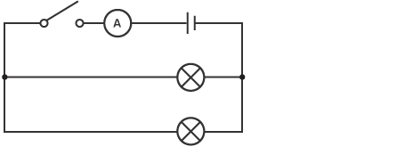

### Potential difference in parallel

Since energy has to be conserved, the energy transferred around the circuit by the electrons is the same whichever path the electrons follow. Since potential difference is used to measure changes in energy, the potential difference supplied is equal to the potential differences across each of the parallel components:

VS = V1 = V2

Circuit containing a switch, 6V battery and two 100 ohm resistors in parallel. Label 1 points to a voltmeter connected across the battery, marked Vs. Labels 2 and 3 point to voltmeters connected across each resistor, marked V1 and V2 respectively.

### Resistance in parallel

If resistors are connected in parallel the supply current is divided between them. The overall resistance is reduced as the current may follow multiple paths.

**In parallel circuits:**

* the total current supplied is split between the components on different loops
* potential difference is the same across each loop
* the total resistance of the circuit is reduced as the current can follow multiple paths

**Energy and power in electric circuits**

As electrons flow through wires, they collide with the ions in the wire which causes the ions to vibrate more. This increased vibration of the ions increases the temperature of the wire. Energy has been transferred from the chemical energy store of the battery into the internal energy store of the wire.

The amount of energy transferred each second (power) between the energy stores can be calculated using the equation:

power = current × potential difference (P = I x V)

* power (*P*) is measured in watts (W)
* current (*I*) is measured in amps (A)
* potential difference (*V*) is measured in volts (V)

One watt is equal to one joule per second (J/s).

Power can also be written as:

power = current2 × resistance (P = I2 x R)

* power (*P*) is measured in watts (W)
* current (*I*) is measured in amps (A)
* resistance (*R*) is measured in ohms (Ω)

### **Example**

How much energy is transferred each second by a current of 2 amps (A) driven by a potential difference of 230 volts (V)?

P = I x V = 2 x 230 = 460W

**Questions**

# Conversion of units

Give your answer to questions 1-4 in standard form.

1. Convert the following voltages to V

6 kV 34 MV 328 mV 893 µV

1. Convert the following lengths to m

364 mm 98 cm 459 nm 28.7 µm

1. Convert the following energies to J

23mJ 439 GJ 2.5 pJ 34 TJ

1. Convert the following powers to W

359 MW 962 mW 785 nW 285 µW

1. Convert the following frequencies to GHz

34 mHz 34 µHz 34 MHz 34 Hz

1. Convert the following currents to mA

23 x 10-4 A 247 µA 857 x 10-5 A 25 µA

1. Convert the following powers to MW

2650 GW 2240 kW 260 mW 379 TW

**Algebra**

1. The equation for speed is: *s = d / t*
2. Rearrange the equation to make *d* the subject
3. Calculate the distance travelled by a car travelling at 15 ms-1 for 40 seconds
4. The equation for force is: *F = ma*
5. Rearrange the equation to make *m* the subject
6. What is the mass of an object if a force of 50N gives an acceleration of 5ms-2?
7. The equation for weight is: *W= mg* (W is weight, use g = 10 ms-2)
8. Rearrange the equation to make *m* the subject
9. Calculate the mass of an object if the weight is 150N

1. The equation of gravitational potential energy is: *GPE = mgh* (use g = 10 ms-2)
2. Rearrange the equation to make *h* the subject
3. Calculate the height if an object of mass 6kg has a GPE of 1200 Joules
4. The equation for acceleration is: *a = (v – u) / t* (v is final velocity, u is initial velocity)
5. Rearrange the equation to make *v* the subject
6. The acceleration of a car is 2 ms-2. The initial speed is zero and it travels for 15 seconds.

Calculate the final velocity (*v*).

1. The equation for kinetic energy is: *KE = ½ mv2*
2. Rearrange the equation to make *v* the subject
3. Calculate the velocity of an object of mass 10kg which has a KE of 750J

**Velocity-time graphs**

5

10

**O**

15

20

4

8

12

**t/s**

**v/ms-1**

**A**

**B**

**C**

1. The graph of *velocity against time* for a motorcyclist traveling in a straight line is shown on the right.
2. what is the acceleration from O to A?
3. what is the change of displacement O to A?
4. what is the acceleration from B to C?
5. what is the total change of displacement?
6. A car speeds up from 3ms-1 to 12 ms-1 in 4.5 seconds. What is its acceleration? 

10

20

0

30

40

20

40

60

**t/s**

**s/m**

1. For the *displacement-time* graph shown on the right:

a) what is its velocity between 0 and 20s?

b) what is its velocity between 30 and 40s?

c) describe the motion between 20s and 30s

**Forces - Dynamics**

1. Calculate the quantities indicated:
2. a = 2.5ms-2, m = 3.0kg, F =
3. F = 15N, m = 30kg, a =
4. a = 2.5 ms-2, F = 7.5N, m=
5. A bike has a mass of 14kg and its rider has a mass of 82kg. The rider provides a horizontal force of 60N. What is the acceleration?
6. A car of mass 500kg is traveling along a flat road. Its engine provides a forward force of 300N. Air resistance is 200N. What will its acceleration be?

Equations of Uniform Acceleration

If an object moves with constant (uniform) acceleration, we must use one of the following equations.

*v = u + at s = ut + ½ at2  v2 = u2 + 2as s = (u+v)t / 2*

Where *v* is final velocity, *u* is initial velocity, *s* is displacement (distance), *t* is time, *a* is acceleration

Method: First write down the latter of the values you know and the value you want to find. Then select the correct equation which contains all 4 values. Rearrange the equation if necessary then substitute in the values to find the answer.



1. A car has a constant acceleration of 1.5ms-2. Its initial velocity is 3.5ms-1. Find:
2. its velocity after 7 seconds
3. the distance traveled in order to reach a velocity of 25ms-1
4. An object is dropped from the top of a high building. It has an acceleration of 10ms-2. As it is dropped its initial velocity is zero. Find:
5. its velocity after 2.2s
6. how far it has traveled after 1.6s
7. the change in displacement in order to reach a velocity of 28ms-1

**Work and energy**

1. Calculate the *work done* in each case below
   1. A force of 15N moves a distance of 4m
   2. A leg muscle exerting a force of 300N over a distance of 0.02m.
   3. A 20N weight lifted through a height of 2m
2. How much *gravitational potential energy* does a 15kg box gain when lifted vertically 5m?
3. Find the *gravitational potential energy* of a 750kg car at the top of a hill of height 1200m.
4. A rhinoceros moves at a speed of 15m/s and its mass is 750kg. What is its *kinetic energy*?
5. Find the *kinetic energy* of a plane with a mass of 20,000 kg and a velocity of 200m/s
6. Find the *speed* of the following objects:
   1. a car of mass 1000kg with a KE of 200,000J
   2. a bullet of mass 50g with a KE of 56,300J (HINT: change g into kg)

**Electricity - Charge and current**

1. What current flows if a charge of 25C passes a point in 2s?
2. What is the current when a charge of 24C passes in 2 minutes?
3. What charge passes a point if 3.2A flows for 6s?
4. How much charge passes a point if a current of 5mA flows for 30 minutes?
5. How long would it take for 100C to pass if a current of 5A is flowing?
6. A charge of 500C is required to electroplate a metal object. The current in the process is 200mA. Calculate how long the process will take.

**Electricity - Voltage**

1. Use the equation *V = E/Q* to answer the following questions:
2. what is the voltage when 200J is given to a charge of 50C?
3. what is the voltage when 100J is given to a charge of 2mC?
4. how much energy is transferred by 5C moving through a voltage of 12V?
5. how much energy is transferred by 100mC when the voltage is 20V?
6. if a 6V battery transfers 30mJ, how much charge passes round the circuit?
7. In an electric kettle, a supply of 300,000J of energy is required in 120s. If the supply voltage 230V, calculate: a) the charge supplied b) the current in the kettle

**Electricity – Resistor networks**

What is the missing voltage in the following circuits?

1. over resistor R2
2. the supply voltage, V
3. the voltage over each resistor, R, if they have the same resistance.



R

R

Q

c)

24V

V

R4

R3

9V

9V

b)

12V

R1

R2

V

8V

a)

**Answers**

**Units**

1. Convert the following voltages to V:

6 kV = 6 x 103 V 34 MV = 3.4 x 107 V

328 mV = 3.28 x 10-1 V 893V = 8.93 x 10-4 V

2. Convert the following lengths to m:

364 mm = 3.64 x 10-1 m 98 cm = 9.8 x 10-1 m

459 nm = 4.59 x 10-7 m 28.7 μm = 2.87 x 10-5 m

3. Convert the following energies to J:

23 mJ = 2.3 x 10-2 J 439 GJ =4.39 x 1011 J

2.5 pJ = 2.5 x 10-12 J 34J = 3.4 x 1013 J

4. Convert the following powers to W:

359MW = 3.59 x 108 W 962 mW =9.62 x 10-1 W

785 nW = 7.85 x 10-7 W 285 µW = 2.85 x 10-4 W

5. Convert the following frequencies to GHz:

34 mHz = 34 x 10-3  x10-9 GHz = 3.4 x 10-11 GHz 34 μHz = 3.4 x 10-14 GHz

34 MHz =3.4 x 10-2 GHz 34Hz = 3.4 x 10-8 GHz

6. Convert the following currents to mA:

23 x 10-4 A = 23 x 10-4 x103 mA = 2.3 mA 247 μA =2.47 x 10-1 mA

857 x 10–5 A= 8.57 mA 25μA = 2.5 X 10-2 m A

1. Convert the following powers to MW:

2650 GW = 2650 x109 x 10-6 MW = 2.65 x 106 MW 2240 kW = 2.24 MW

260 mW = 2.60 x 10-7 MW 379 TW = 3.78 x 108 MW

**Algebra**

1. a) d = s x t b) 600m
2. a) m = F /a b) 10 kg
3. a) m = W / g b) 15 kg
4. a) h = GPE / mg b) 20 m
5. a) v = u + at b) 30 ms-1
6. a) v = √(2KE/m) b) 12.2 ms-1

**Velocity-time graphs**

1. 2ms-2
2. 25m
3. -4ms-2
4. 162.5m
5. 2ms-2

a) 3ms-1 b) -6ms-1 c) stationary

**Forces - Dynamics**

1. 7.5N
2. 0.5ms-2
3. 3kg
4. 0.625ms-2
5. 0.2ms-2

Equations of Uniform Acceleration



1. 14ms-1
2. 204m
3. 22ms-1
4. 12.8m
5. 39.2m

**Work and Energy**

1.

a) 60J b) 6J c) 40J

2. 736J

3. 8.8 x 106 J

4. 84,375 J

5. 4 x 108 J

6. a) 20 m/s b) 1500 m/s

**Electricity - Charge and current**

1.  12.5A

2.  0.2A

3. 19.2C

1. 9C
2. 20 s

6 .2500 s

**Electricity - Voltage**

1.

a) 4V

b) 50,000V

c) 60J

d) 2J

e) 5x10-3J

2. a) 1304C b) 10.9A

**Electricity – Resistor networks**

1. 4V
2. 9V
3. 12V