

**Course Start**

Course Start is independent learning you need to complete as a fundamental part of your introduction to the course. It should take you approximately 5 hours to complete.

|  |  |
| --- | --- |
| Course Name | **Criminology** |
| How this **Course Start** fits into the first term of the course | The first unit that we study is **Unit 1: Changing Awareness of Crime**. These tasks will introduce you to the different types of unreported crime.  The three that you will cover in the course start tasks are: *White collar, hate crime, honour crime.*  This will involve research skills and note taking which will prepare you for the controlled assessment. |
| How will my **Course Start** learning be used in lessons? | In the first 2-3 weeks, we shall be referring to the six different types of unreported crime. It will form the basis of the first half term’s learning.  The three crimes that you will be analysing as part of these tasks are flipped and so we will be reviewing what you have researched as part of the first few lessons back. |
| **Course Start** learning objectives | * To be able to analyse different types of crime: White collar, hate crime, honour crime. * Analysis should involve: criminal offences, types of victims, types of offenders, level of public awareness, criminal or deviant and a real case study. |
| Study Skills | * **Research skills** - using suggested sources and identifying key information * **Communication skills** - putting your ideas and findings into effective writing * **Note taking** - the first form of assessment is the CA at the end of the first term. Students are able to use notes in this assessment to support them. |

**Expectations for: Criminology**

Our specification is: [Criminology-level-3 Diploma Specification](https://www.wjec.co.uk/qualifications/criminology-level-3/#tab_keydocuments)

|  |
| --- |
| **What this course involves** |
| Completing Planned Study (independent learning) of 5 hours per week. |
| Completing two controlled assessments (8 hours each) over the two year course. These form 50% of your overall grade. This entails using the notes that you have created over the term to apply and analyse a scenario given to you. |
| Completing two exam units (each is a 90 minute exam paper). These form the other 50% of your overall grade. This is a typical exam set up (questions range from 1 - 9 marks) with no access to notes or other resources during the assessment. |
| Engaging in discussions and presentations based on the topics studied. |
| Studying a diverse range of themes: theories for criminality including psychology, sociology, biology. Campaigns for change, analysis of the crime scene, the roles within the criminal justice system, how a trial operates within the courtroom and the personnel involved. |
| Developing independent learning skills (e.g. time management, preparing for each week’s lessons, completing learning tasks outside lessons) |
| Writing tasks involving a range of practice exam questions (e.g. short answers of 1 mark up to 9 marks) |

**WJEC DIPLOMA IN CRIMINOLOGY**

Unit 1: Changing awareness of crime

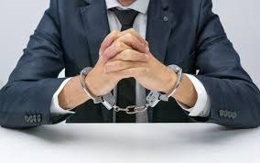

Learning Objective 1: Understand How Crime Reporting Affects the Public Perception of Criminality

**AC1.1 Analyse Different Types of Crime**

* **White Collar Crime**

Name:

**AC1.1: Analyse different types of crime**

|  |  |  |
| --- | --- | --- |
| **Assessment Criterion** | **Mark Band 1** | **Mark Band 2** |
| **AC1.1 You should be able to:**  Analyse different types of crime | Describe different types of crime using examples **(1-2)** | Analysis of types of crime using a range of relevant examples **(3-4)** |

**Amplification:** You should have knowledge of specific examples of different types of crime and be able to analyse them by:

* Criminal offences
* Types of victim
* Types of offenders
* Level of public awareness
* A real life example where possible
* You should know that these acts may be deviant and or criminal

**Content:**Types of crime

* White collar crime, including:

Organised

Corporate

Professional

* Moral Crime
* State Crime, including:

Human rights

* Technological Crime, including:

e-crime

* Individual Crime, including:

Hate crime

Honour crime

Domestic abuse

**AC1.1 Analyse different types of crime**

**Intro Questions:**

1. **Make a list of 5 crimes that you have heard about recently in the media**
2. **For each crime – who are the victims?**
3. **Why do you think certain kinds of crime receive a lot of media attention in comparison to others?**

**Definitions:**

 **What is meant by ‘criminal,?**

** What is meant by ‘deviance’?**

Make a list of behaviours that fit into each of the following categories:

|  |  |  |
| --- | --- | --- |
| Criminal and Deviant | Deviant but not Criminal | Criminal but not Deviant |
| e.g. theft | e.g. shouting in a library | E.g. underage drinking in the UK |

**White- Collar Crime**

**What is the definition of white collar crime?**

|  |
| --- |
| **Communication skills** - ensure that this definition is written in your own words. |

**Write down the 3 different TYPES of white collar crime:**



**Offender and Victim** 

**Who is most likely to commit white collar crime?** *(Do some research, and include stats and facts e.g. what % of offenders are male/female)*

**Who is most likely to be a victim?** *(Do some research and include stats and facts)*

**What is a Ponzi Scheme?**

**What is a pyramid Scheme?**

**Extension:**

**What’s the difference between these two types of scams?**

**Examples:**

**Bernie Madoff:**

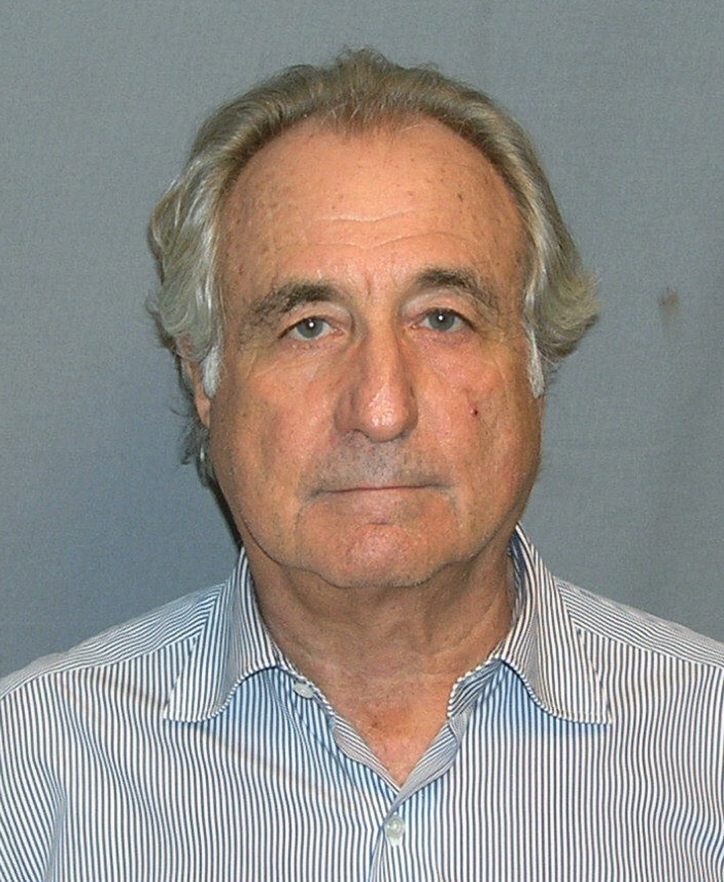

Research task: Consider the case of Bernard Madoff and Ponzi Schemes. Summarise below.

<http://news.bbc.co.uk/1/hi/business/8124838.stm>

**Research to find your own real life example of White Collar Crime:**

**Who was it?**

**When did it happen?**

**What happened? (Summarise the case into bullet points)**



**What kind of White Collar Crime was it? How do you know this?**



**Find a film that shows White Collar Crime and explain what type of White Collar Crime is shows:**

**Level of public awareness**

 Public awareness is the public’s level of understanding about the importance and implications of something



**Do you think the public awareness of White Collar crime is high or low, and why?**

**Is White Collar Crime deviant or criminal? Highlight your answer below and write a brief explanation of why (remember it could be both!):**

**DEVIANT OR CRIMINAL**

**Explain your answer:**

**Create a visually appealing newspaper front page special about organised crime.**

**This could be on The Mafia, The Triads (China), The Yakuza (Japan).**

* **If you do this by hand, please bring it to your FIRST lesson after the summer.**
* **If it is electronic, copy and paste it here/ insert screenshot here.**

**Individual Crime**

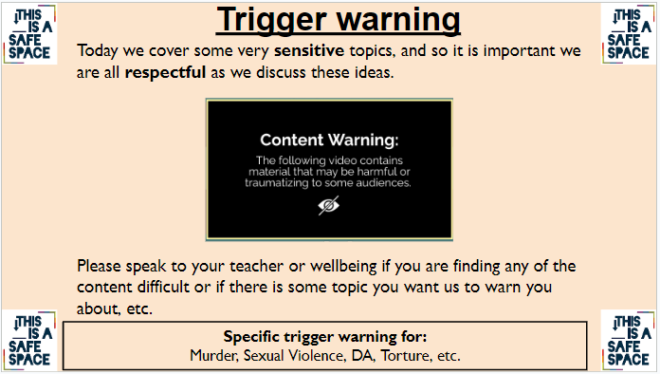

**The following links might help you with the tasks that follow:**

[**Hate crimes surge by 42% in England and Wales since Brexit result | The Independent**](http://www.independent.co.uk/news/uk/crime/brexit-hate-crime-racism-stats-spike-police-england-wales-eu-referendum-a7126706.html)

[**Hate crime - Victim Support**](https://www.victimsupport.org.uk/crime-info/types-crime/hate-crime)

[**Stop Hate UK**](http://www.stophateuk.org/)

[**Stonewall| LGBT in Britain - Hate Crime**](https://www.stonewall.org.uk/lgbt-britain-hate-crime-and-discrimination)

**Hate Crime**

**What is the definition of hate crime?**

|  |
| --- |
| **Communication skills** - ensure that this definition is written in your own words. |

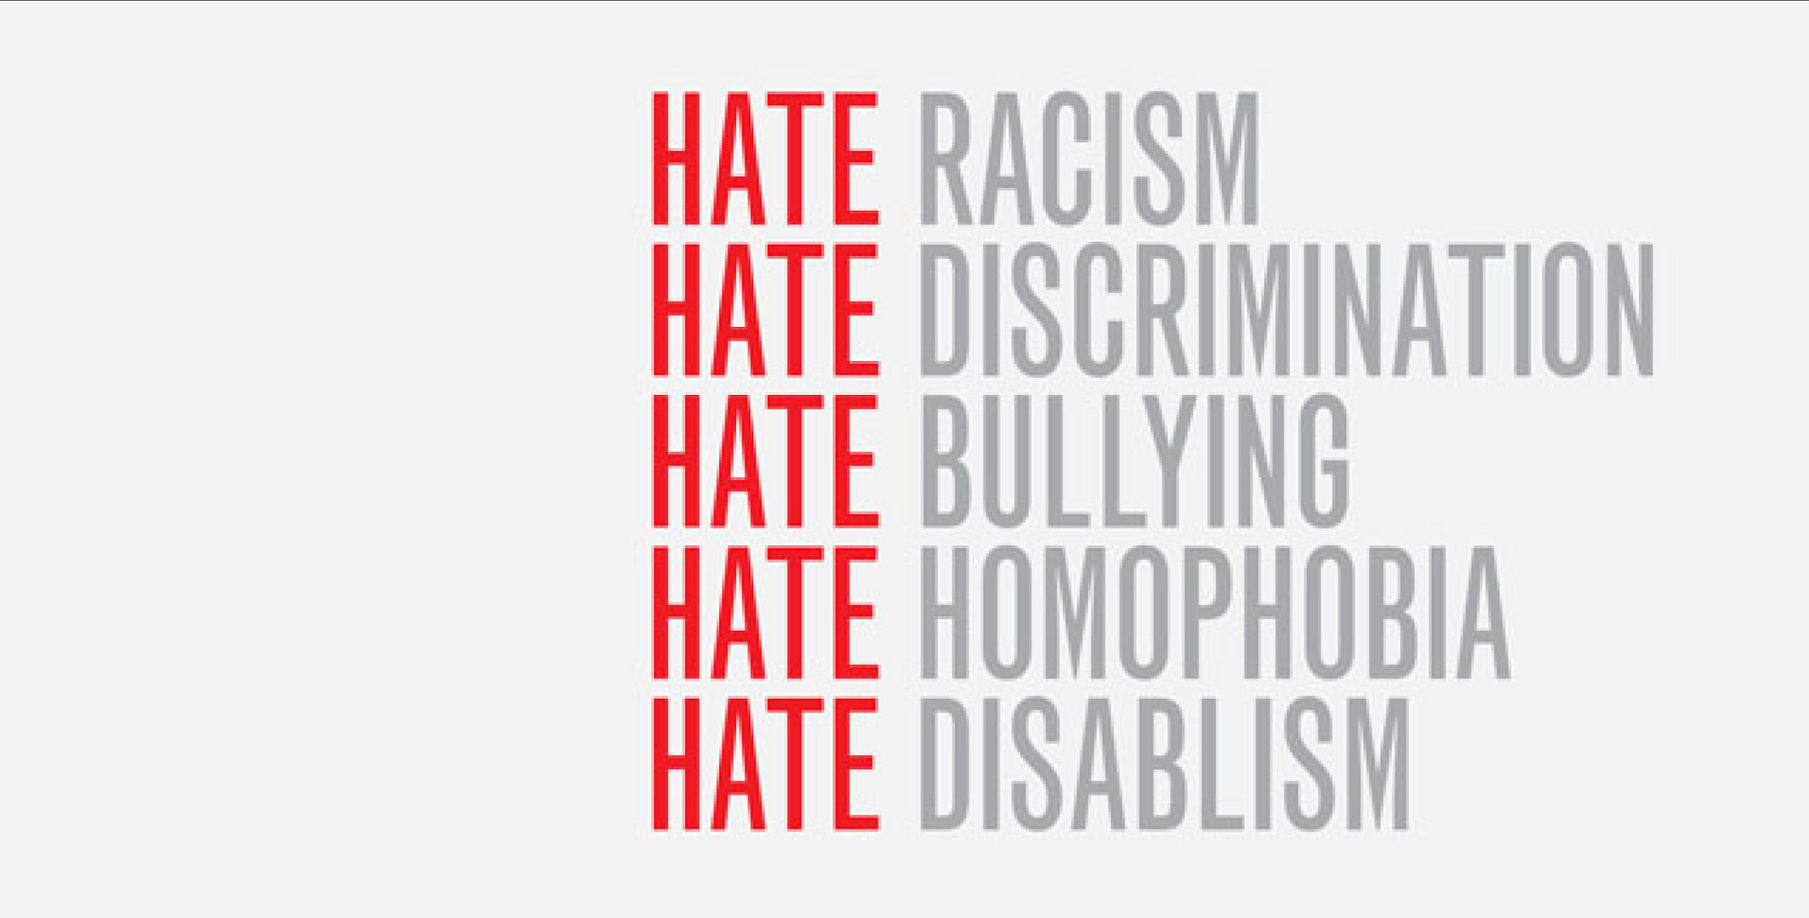

**Victims**

**Identify why each of the groups represented in these images might experience a hate crime:**

|  |  |
| --- | --- |
| C:\Users\anna.plummer\AppData\Local\Microsoft\Windows\INetCache\Content.MSO\92D035AD.tmp |  |

|  |  |
| --- | --- |
| C:\Users\anna.plummer\AppData\Local\Microsoft\Windows\INetCache\Content.MSO\FE88F93F.tmp |  |

|  |  |
| --- | --- |
| C:\Users\anna.plummer\AppData\Local\Microsoft\Windows\INetCache\Content.MSO\3DEEC268.tmp |  |

**Now, list the (five) main protected groups that can be victims of Hate Crimes:**



**Offenders**

Who are typical offenders (who are likely to commit hate crimes)? Why?

Quickly, Do 5 minutes of research and find statistics that can back up what you have written about the typical victims and offenders

**Case study - Adam Pearson:**

[The Ugly Face of Disability Hate Crime - BBC Documentary](https://www.youtube.com/watch?v=B03jduD9N5o&safe=active)

While you’re watching, consider why this is a hate crime. Consider how this will affect the gentleman’s everyday life.

Summarise the case below:

What type of punishment do you think would be appropriate for this type of crime?

Use Google to research a hate crime which has recently taken place. (The BBC website will be a good source of information) and fill in this box with notes on hate crime…

Think about the politics of the last 10 Years - can you think of anything that would affect the rates of Hate Crime? - Explain how these events might be affecting the rates of Hate Crime

Do you think the **public awareness** is high or low, and why? (Hint: do we hear about hate crimes in the media). Are there certain types of hate crime that are more likely to be reported than others?

Is hate crime deviant or Criminal? Circle your answer and write a brief explanation of why (remember it could be both!):

**DEVIANT OR CRIMINAL**

Find a campaign material (e.g. poster) from a Hate Crime campaign- copy and paste this onto your document below:

Now, answer the following questions:

* Make at least three observations about the design choices of the campaign
  + Colour choices, images, language, etc.
* Next, **plan** your own campaign - you do NOT have to design the poster, but plan a campaign on ‘**Hate Crime**’

**Extension:**

Have you heard the term ‘Incel’ before? What does this refer to?

What does it have to do with our discussions about Hate Crime?

Do you think they should be labelled as a terrorist group? Why do you think they are often not?



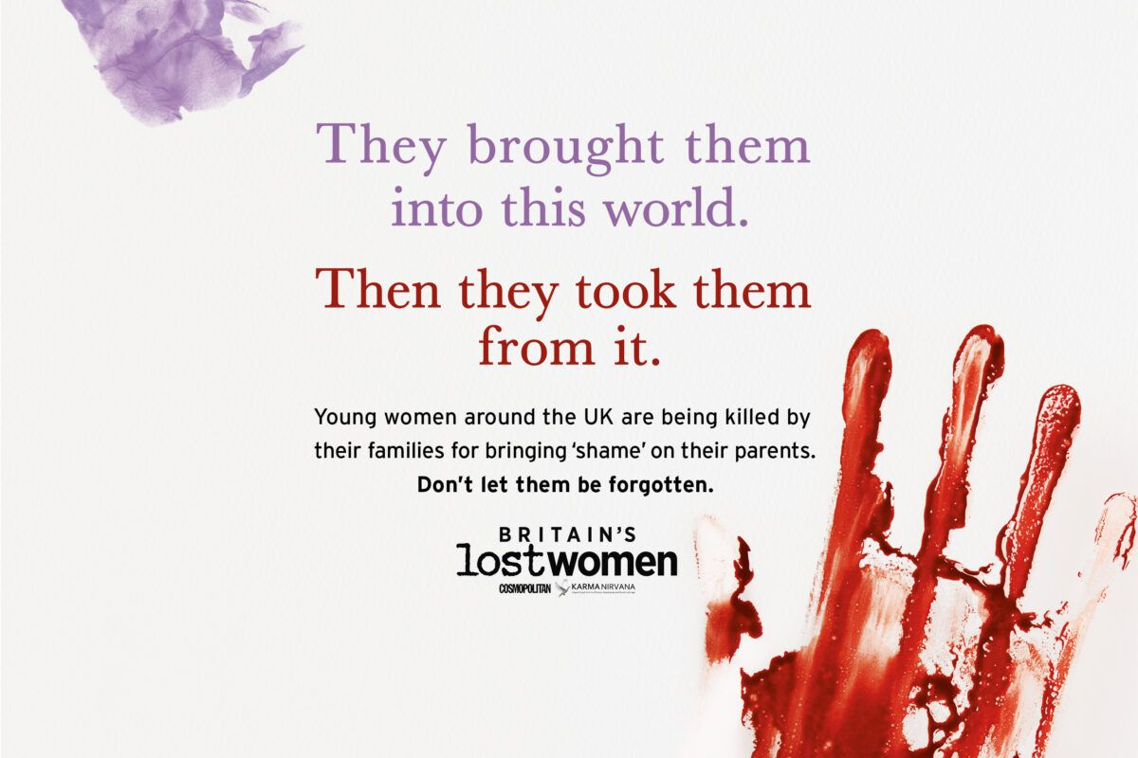

**Individual Crime**

**Honour crime**

*Read the following link first to help you answer the questions below:* [BBC - Ethics - Honour crimes](http://www.bbc.co.uk/ethics/honourcrimes/crimesofhonour_1.shtml)

**What is the definition of honour crime?**

**Give 4 examples of Honour Based Violence (HBV):**

4. 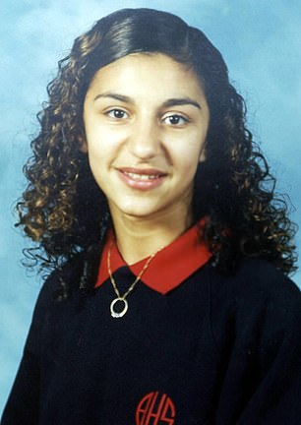

**Real Life Example:**

|  |
| --- |
| **Research the case of Heshu Yones:**  *Helpful links:*  [The tragic schoolgirl victim of UK's first 'honour killing' | Daily Mail Online](https://www.dailymail.co.uk/femail/article-9270103/The-tragic-schoolgirl-victim-UKs-honour-killing.html)  [Kurd who slit daughter's throat in 'honour killing' is jailed for life | UK news | The Guardian](https://www.theguardian.com/uk/2003/sep/30/religion.world)  [Heshu's boyfriend tells of loss | London Evening Standard](https://www.standard.co.uk/hp/front/heshu-s-boyfriend-tells-of-loss-6969045.html)  [Execute me, pleads Muslim who killed his daughter over her Western lifestyle | The Independent](https://www.independent.co.uk/news/uk/crime/execute-me-pleads-muslim-who-killed-his-daughter-over-her-western-lifestyle-89140.html)  Who was the victim?  Who was the offender/s?  When did it happen?  What happened? (Summarise the case into bullet points)        What kind of Honour Based Violence was it? |

|  |
| --- |
| **NOW, research your own case of Honour Based Violence/ Honour Killing:**  *Use the links below to help you if you get stuck.*  Who was the victim?  Who was the offender/s?  When did it happen?  What happened? (summarise the case into bullet points)        What kind of Honour based Violence was it?  *Helpful links/articles:*   * [Builder found guilty of kidnapping, raping and cutting throat of niece - The Independent](https://www.independent.co.uk/news/uk/crime/mujahid-arshid-trial-latest-man-rape-niece-murder-freezer-taser-celine-dookhran-south-west-london-builder-a8211136.html) * [Uzma Arshad: The Westernised wife - Manchester Evening News](https://www.manchestereveningnews.co.uk/news/greater-manchester-news/uzma-arshad-the-westernised-wife-985233) * [Taxi driver guilty of bludgeoning family to death | UK news | The Guardian](https://www.theguardian.com/uk/2007/mar/13/ukcrime) * [Harry Potter star Afshan Azad's brother jailed over three-hour 'honour' attack - Manchester Evening News](https://www.manchestereveningnews.co.uk/news/local-news/harry-potter-star-afshan-azads-852273) * [Honour killings - BBC News](https://www.bbc.co.uk/news/topics/c207p54m43qt) |

Who is more likely to be an **offender** and a **victim** of honour crime?

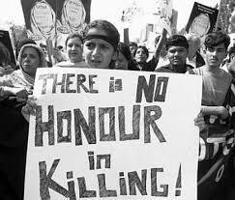

Do you think **public awareness** is high or low, and why?



**Is honour crime deviant or Criminal? Circle your answer and write a brief explanation (remember it could be both!):**

**DEVIANT OR CRIMINAL**

**Explain your answer:**

**EXTENSION VIDEO TASK:**

**Watch this BBC short drama film about Honour Killings in the UK:**

[**Murdered by My Father - BBC iPlayer**](https://www.bbc.co.uk/iplayer/episode/p03nnns9/murdered-by-my-father)